**Contents**

***ABSTRACT***

***LIST OF FIGURES***

**1. Introduction**

- Background and motivation for the project

- Problem statement highlighting the challenges in tender management

- Objectives of the thesis and system development

**2. Literature Review**

- Overview of tender management systems and their significance

- Evaluation of existing systems and their limitations

- Analysis of technologies used in tender management systems

- Review of related studies and projects in the field

**3. System Analysis**

- Requirement gathering and analysis process

- Use case diagrams illustrating system functionalities

- Entity-Relationship diagrams for data modeling

- Data flow diagrams depicting system processes

- Description of the system architecture

**4. System Design**

- Design principles and patterns applied in the system

- Database design, including tables, relationships, and normalization

- User interface design for a user-friendly experience

- Security and access control design to ensure data integrity and confidentiality

- System integration design for seamless functionality

**5. System Implementation**

- Java programming with JDBC for database connectivity

- Utilizing Servlets and JSP for web development

- Implementation of the MySQL database to store tender information

- Development and integration of key features and modules in the system

**6. System Testing and Evaluation**

- Test plan creation and formulation of test cases

- Conducting unit testing to verify individual components

- Integration testing to ensure proper system functionality

- User acceptance testing for user feedback and validation

- Performance evaluation to measure system efficiency

**7. Results and Discussion**

- Evaluation of system functionality and its adherence to requirements

- Assessment of the user experience and system usability

- Comparison with existing tender management systems

- Identification of limitations and suggestions for future enhancements

**8. Conclusion**

- Summary of the achievements in developing the Tender Management System

- Contributions to knowledge in the field of tender management

- Recommendations for future research and system improvements

**9. References**

- Properly cited sources used in the thesis

**10. Appendix A:**

Use case diagrams

**11. Appendix B:**

Entity-Relationship diagrams

**12. Appendix C:**

Data flow diagrams

**13. Appendix D:**

Source code snippets

**14. Appendix E:**

Test cases and results

**15. Appendix F:**

User feedback forms or surveys

**LIST OF FIGURES**

Figure 1.1 RDBMS Design

Figure 1.2 MVC Project designing Flow Chart

Figure 1.3 SEM bids Evluation

Figure 1.4 Measurment Units

Figure 1.5 Contrat Lifecycle

Figure 1.6 UML Diagram Of Tender Management System

Figure 1.7 Supplier Login Diagram for contact Management System

Figure 1.8 Design database

Figure 2.1 Home page screen

Figure 2.2 Code for home page

Figure 2.3 Home page for register new vendor

Figure 2.4 Code for register new vendor

Figure 2.5 Welcome page for new vendor

Figure 2.6 Code for new vendor

Figure 2.7 View vendor id and vendor name

Figure 2.8 Code for view vendor id and vendor name

Figure 2.9 View all tendors

Figure 2.10 Code for all tendors

Figure 2.11 View page for create new tendor

Figure 2.12 Code for create new tendor

Figure 2.13 View page for add new tender

Figure 2.14 It is for accept a bid

Figure 2.15 Viewing all the accepted tenders

Figure 2.16 View page for add a notice

Figure 2.17 View page for remove a notice

Figure 2.18 View page for user login screen

Figure 2.19 View page for all tender home screen page

Figure 2.20 View page for change the password

Figure 2.21 View page for account details

Figure 2.22 View page for changing vendor password

Figure 2.23 Code for Galary page

**LIST OF TABLES**

Table 1.1 Admin Table

Table 1.2 Supplier Table

Table 1.3 Master Specification Table

Table 1.4 Tender Table

Table 1.5 Tender Specification Table

Table 1.6 Query Table

Table 1.8 Bids Table

**ABSTRACT**

This thesis presents the development of a Tender Management System utilizing advanced Java technologies. The system aims to streamline and automate the tendering process, providing a comprehensive solution for tendering authorities and bidders. By leveraging the power of Java and web-based architectures, the system offers a user-friendly interface, document management, automated notifications, and secure bidding mechanisms to ensure transparency and efficiency in the tendering process.

The Tender Management System addresses key challenges faced in traditional tendering processes by providing functionalities such as tender notice publication, bid submission and evaluation, communication and clarification, contract awarding, and reporting and analytics. These features enable tendering authorities to effectively manage the entire tender lifecycle, from the initial publication of tender notices to the final contract awarding.

Through the system's intuitive interface, tendering authorities can publish detailed tender notices, outlining project requirements and submission guidelines. Bidders can then submit their bids electronically, eliminating the need for physical paperwork and enabling secure storage and management of bid documents. The system incorporates evaluation tools and algorithms to assist in the assessment and comparison of bids based on predefined criteria, ensuring fairness in the selection process.

Effective communication between tendering authorities and bidders is facilitated by the system, allowing for seamless interaction, clarification of queries, and prompt responses. This communication feature enhances transparency and reduces misunderstandings during the tendering process.

Upon completion of the evaluation process, the system facilitates the awarding of contracts to successful bidders. Automated notifications are generated to inform all stakeholders about the outcome of the tender, ensuring transparency and timely communication.

Furthermore, the system provides comprehensive reporting and analytics capabilities, enabling tendering authorities to generate detailed reports on tender progress, bid statistics, and historical data. These insights assist in making informed decisions and improving future tender processes.

The development of the Tender Management System utilized advanced Java technologies, including web-based architectures, database management systems, and security frameworks. These technologies contribute to the system's robustness, scalability, and security, ensuring the efficient and secure handling of sensitive tender-related information.

Overall, the developed Tender Management System using advanced Java technologies offers a holistic solution to enhance the tendering process. Its features empower tendering authorities and bidders with efficient management, transparency, and improved decision-making capabilities.

**INTRODUCTION**

Chapter 1: Introduction

1.1 Background and Motivation

The procurement and tendering processes play a crucial role in various industries and sectors, enabling organizations to acquire goods, services, and projects from external vendors. However, the traditional manual tender management approach often leads to inefficiencies, delays, and errors. In light of these challenges, the development of an automated Tender Management System is essential to streamline the tendering process, enhance transparency, and improve vendor selection.

1.2 Problem Statement

The manual management of tenders poses several challenges, such as the cumbersome handling of large volumes of paperwork, difficulty in tracking tender status, lack of standardized evaluation criteria, and limited accessibility for all stakeholders involved. These issues not only lead to increased administrative overheads but also compromise the fairness and competitiveness of the tendering process.

1.3 Objectives

The primary objective of this thesis is to design, develop, and evaluate a Tender Management System using Java, JDBC, Servlets, JSP, and MySQL Database. The system aims to address the limitations of manual tender management by providing an efficient and user-friendly platform for managing tender information, document submissions, evaluation, and vendor selection. The specific objectives of the thesis include:

- Analyzing the requirements of a Tender Management System and understanding the needs of the stakeholders involved.

- Designing an architecture that encompasses the essential functionalities of the system, ensuring scalability, security, and ease of use.

- Implementing the system using Java programming with JDBC for database connectivity, Servlets, and JSP for web development, and MySQL Database for data storage.

- Conducting comprehensive testing to validate the system's functionality, performance, and reliability.

- Evaluating the system's effectiveness and usability through user acceptance testing and gathering feedback from stakeholders.

- Comparing the developed system with existing tender management systems and identifying its advantages, limitations, and areas for improvement.

1.4 Scope and Limitations

The scope of this thesis focuses on the design, development, and evaluation of the Tender Management System using the specified technologies. The system will provide features for managing tender information, document submissions, evaluation, and vendor selection. However, the thesis does not cover financial aspects, such as payment processing or integration with accounting systems.

1.5 Thesis Organization

This thesis is organized into several chapters to provide a systematic approach to the research and development of the Tender Management System. The following chapters will be covered:

These chapters will collectively provide a comprehensive understanding of the research conducted, the development process, and the evaluation of the Tender Management System.

By addressing the challenges of manual tender management and leveraging the capabilities of Java, JDBC, Servlets, JSP, and MySQL Database, this thesis aims to contribute to the advancement of tender management practices and provide a valuable tool for organizations in the procurement process.

Chapter 2: Literature Review

2.1 Overview of Tender Management Systems and Their Significance

The Literature Review section provides an overview of tender management systems and highlights their significance in the procurement process. It explores the evolution of tender management practices and the transition from manual processes to automated systems.

The review begins by discussing the fundamental concepts of tender management systems. It explains how these systems are designed to facilitate and streamline the entire tendering process, from the initial announcement to the final vendor selection. It covers key aspects such as tender document management, evaluation criteria, bid submission, and contract awarding.

The section highlights the significance of tender management systems in improving efficiency and transparency. It explores how these systems help organizations save time and resources by automating manual tasks, reducing paperwork, and centralizing tender-related information. It emphasizes the importance of transparency in the tendering process, ensuring fair competition and equal opportunities for vendors.

Furthermore, the review discusses the benefits of using tender management systems for both buyers and vendors. For buyers, these systems provide a structured and standardized approach to managing tenders, allowing for better evaluation of bids, faster decision-making, and enhanced vendor selection. For vendors, these systems offer a centralized platform to access and respond to tenders, enabling them to submit bids efficiently and track their status.

The section also highlights the role of technology in tender management systems. It explores how advancements in software development, database management, and web-based applications have revolutionized the way tenders are managed. It discusses the use of technologies such as Java, JDBC, Servlets, JSP, and MySQL Database in developing robust and scalable tender management systems.

Overall, the Literature Review section provides an overview of tender management systems, their significance in the procurement process, and the advantages they offer to both buyers and vendors. It establishes a foundation for understanding the context and importance of developing an automated Tender Management System using Java, JDBC, Servlets, JSP, and MySQL Database.

Certainly! Here's a brief description of the Existing Systems and Their Limitations section in the Literature Review:

2.2 Existing Systems and Their Limitations

In this section, the focus is on evaluating the limitations of existing tender management systems. A review of various systems currently in use provides insights into the challenges faced by organizations in managing tenders and highlights the need for an improved solution.

The section begins by identifying and examining a range of existing tender management systems. These systems may vary in terms of features, functionalities, technology platforms, and deployment models. They could be commercial off-the-shelf (COTS) solutions or custom-developed systems.

The limitations of these existing systems are then analyzed. Common challenges include:

1. Lack of user-friendliness: Many existing systems suffer from complex user interfaces and cumbersome navigation, making it difficult for users to navigate through the tendering process efficiently.

2. Limited scalability: Some systems may struggle to handle a large volume of concurrent users or a high number of tender submissions, resulting in performance issues and decreased system efficiency.

3. Insufficient customization options: Existing systems often lack flexibility and customization capabilities, preventing organizations from tailoring the system to their specific requirements and workflows.

4. Inadequate document management: Document handling and version control can be problematic in some systems, leading to difficulties in managing and tracking tender-related documents effectively.

5. Incomplete evaluation features: The evaluation process may be limited in some systems, lacking comprehensive evaluation criteria, weighting mechanisms, and automated scoring capabilities.

6. Limited reporting and analytics: Existing systems may provide limited reporting functionalities, making it challenging to generate comprehensive reports and derive meaningful insights from tender data.

7. Inadequate vendor communication: Some systems lack effective communication channels between buyers and vendors, hindering efficient collaboration and information exchange during the tendering process.

8. Security vulnerabilities: Security concerns such as data breaches, unauthorized access, or insecure data storage may exist in certain systems, compromising the confidentiality and integrity of tender-related information.

Certainly! Here's a brief description of the Analysis of Technologies Used in Tender Management Systems section in the Literature Review:

Chapter 2: Literature Review

2.3 Analysis of Technologies Used in Tender Management Systems

In this section, an analysis is conducted to explore the technologies commonly used in the development of tender management systems. The aim is to understand the advantages, limitations, and suitability of these technologies for building robust and efficient systems.

The review focuses on several key technologies employed in tender management systems, including Java, JDBC, Servlets, JSP, and MySQL Database. Each technology is evaluated based on its relevance, functionality, and compatibility with the requirements of tender management systems.

Java, as a popular programming language, provides a robust and versatile platform for system development. Its object-oriented nature, extensive libraries, and cross-platform compatibility make it suitable for building scalable and maintainable tender management systems.

JDBC (Java Database Connectivity) is a Java API that allows Java applications to interact with relational databases. It enables seamless integration between the system and the backend database, such as MySQL. By utilizing JDBC, tender management systems can efficiently store, retrieve, and manipulate tender-related data.

Servlets and JSP (JavaServer Pages) are Java technologies used for web development. Servlets handle the server-side logic of the system, while JSP allows for dynamic content generation and presentation. These technologies enable the development of interactive and user-friendly web interfaces for tender management systems.

MySQL Database, a widely used relational database management system, offers scalability, performance, and reliability. Its support for structured query language (SQL) facilitates efficient data management and retrieval in tender management systems.

The analysis also considers alternative technologies that may be used in tender management systems, such as other programming languages (e.g., Python, PHP), frameworks (e.g., Spring), and databases (e.g., Oracle, PostgreSQL). The pros and cons of these alternatives are explored to understand their suitability in the context of tender management systems.

By analyzing the technologies used in tender management systems, the thesis aims to identify the most appropriate and effective technology stack for the development of the proposed Tender Management System. This analysis ensures that the chosen technologies align with the system requirements, provide robustness, security, and scalability, and offer compatibility with existing infrastructure and industry standards.

By analyzing the limitations of these existing systems, the thesis aims to identify areas of improvement and overcome the challenges faced by organizations in managing tenders effectively. The insights gained from this analysis serve as a basis for the design and development of a robust Tender Management System that addresses these limitations and offers enhanced functionality, usability, and security.

Chapter 2: Literature Review

2.4 Comparison and Evaluation of Existing Tender Management Systems

In this section, a comparison and evaluation of existing tender management systems are performed. The purpose is to assess the advantages, limitations, and effectiveness of these systems based on various criteria.

The review compares different aspects of the systems, including their features, functionalities, user interfaces, performance, scalability, security measures, and integration capabilities. It also considers factors such as deployment models (on-premises, cloud-based), licensing, and vendor support.

By conducting a comparative analysis, the section aims to identify the strengths and weaknesses of each system. This analysis provides valuable insights into the best practices and successful approaches employed by existing tender management systems.

Additionally, the evaluation examines how well these systems align with the requirements and challenges identified in the earlier sections of the literature review. It assesses their ability to address the limitations of manual tender management and improve the overall efficiency and effectiveness of the tendering process.

The evaluation may involve gathering feedback from users, administrators, and procurement professionals who have utilized these systems. It considers their experiences, satisfaction levels, and any specific issues or challenges faced during the implementation and usage of the systems.

Furthermore, the review examines case studies, research papers, or industry reports that discuss the implementation and utilization of tender management systems. These sources provide real-world examples and insights into the practical application and impact of these systems in different contexts.

By comparing and evaluating existing tender management systems, the thesis gains valuable knowledge and perspectives that can be used to inform the design, development, and improvement of the proposed Tender Management System. The findings help in identifying the key features, functionalities, and considerations that should be incorporated to create a comprehensive and efficient solution.

Chapter 3: System Analysis

3.1 Requirement Gathering and Analysis Process

The System Analysis phase involves the systematic gathering and analysis of requirements for the Tender Management System. This phase aims to identify the needs and expectations of stakeholders, define the scope of the system, and determine the key functionalities and features that the system should possess.

The requirement gathering process begins by conducting interviews, surveys, and workshops with various stakeholders involved in the tender management process. This includes procurement managers, administrators, evaluators, vendors, and end-users. Through these interactions, the analyst collects information regarding the current challenges, pain points, and desired improvements in the existing tender management practices.

Additionally, documentation such as tender documents, policies, and regulations related to the tendering process is thoroughly reviewed and analyzed. This helps in understanding the legal and procedural requirements that the Tender Management System needs to comply with.

Once the requirements are gathered, the next step is to analyze and prioritize them. This involves categorizing the requirements into functional and non-functional requirements. Functional requirements describe the specific actions and tasks the system should perform, such as tender document submission, evaluation, and vendor selection. Non-functional requirements define the system's performance, usability, security, and other quality attributes.

To ensure a clear understanding of the requirements, various analysis techniques such as use case modeling, activity diagrams, and user stories can be employed. Use case diagrams help in visualizing the system's interactions with external entities and the functionalities it should support. Activity diagrams provide a visual representation of the system's workflow and the sequence of activities involved in the tender management process. User stories provide concise descriptions of system features from the perspective of different users, aiding in capturing user requirements effectively.

Throughout the analysis process, regular communication and collaboration with stakeholders are essential. This ensures that the analyst captures all the necessary requirements accurately and clarifies any ambiguities or uncertainties.

By the end of the requirement gathering and analysis process, a comprehensive and prioritized list of requirements is established. These requirements serve as the foundation for the subsequent phases of system design, implementation, and testing. They guide the development team in building a Tender Management System that aligns with the stakeholders' needs, streamlines the tendering process, and addresses the identified challenges and limitations.

Chapter 3: System Analysis

3.2 Use Case Diagrams Illustrating System Functionalities

Use case diagrams provide a visual representation of the system functionalities and the interactions between the system and its actors (users or external systems). These diagrams help to capture and communicate the main features and actions of the Tender Management System.

Use Case 1: Submit Tender

```

+--------------+

| Vendor |

+--------------+

|  |
| --- |
| Design Database |

|  |
| --- |
| Code Database |

|  |
| --- |
| Integrate And Text |



|  |
| --- |
| Specification |

|  |
| --- |
| Implementation |



|  |
| --- |
| Design GUI Part |

|  |
| --- |
| Code GUI Part |



|  |
| --- |
| Write User Manual |



**Fig 1.5**

In this use case, the vendor (actor) interacts with the system by submitting a tender. The system allows the vendor to provide all the required information, documents, and bid details for a specific tender.

Use Case 2: Evaluate Tender

In this use case, the evaluator (actor) performs the evaluation process within the system. The system provides the evaluator with the necessary tools to review and rate the received tenders based on predefined evaluation criteria.

Use Case 3: Select Vendor

|  |
| --- |
| Specification |

|  |
| --- |
| Design Database Part |

|  |
| --- |
| Code Database Part |

|  |  |
| --- | --- |
| Design GUI | Modulation |

|  |  |
| --- | --- |
| Code GUI | Black Box Testing |

|  |
| --- |
| Integrate And Text |

|  |
| --- |
| Implementation |

In this use case, the procurement manager (actor) interacts with the system to select a vendor. The system provides the procurement manager with information, evaluation results, and tools to make an informed decision regarding the vendor selection.

Use Case 4: Manage Tender Documents

In this use case, the administrator (actor) manages the tender documents within the system. The system allows the administrator to upload, organize, and maintain the various documents associated with the tendering process.

Chapter 3: System Analysis

3.3 Entity-Relationship Diagrams for Data Modeling

Entity-Relationship (ER) diagrams are used to model the data structure and relationships within the Tender Management System. These diagrams help to define the entities (objects or concepts) in the system, the attributes that describe them, and the relationships between entities.

The ER diagram represents entities as rectangles, attributes as ovals, and relationships as lines connecting the entities. The following are some key entities and relationships that may be included in the ER diagram for the Tender Management System:

1. User Entity:

- Attributes: UserID, Username, Password, Name, Email, Role

- Relationships: Users interact with various system functionalities and perform different roles such as vendor, evaluator, procurement manager, and administrator.

2. Tender Entity:

- Attributes: TenderID, Title, Description, StartDate, EndDate, Status

- Relationships: Tenders are created, managed, and evaluated within the system. They are associated with various other entities such as vendors, evaluation criteria, and documents.

3. Vendor Entity:

- Attributes: VendorID, Name, ContactInfo, CompanyName

- Relationships: Vendors participate in tenders by submitting their bids and associated documents. They are linked to specific tenders and evaluation results.

4. Evaluation Criteria Entity:

- Attributes: CriteriaID, Description, Weightage

- Relationships: Evaluation criteria define the criteria used to evaluate the submitted tenders. They are associated with the evaluation process and the scoring of individual tenders.

5. Document Entity:

- Attributes: DocumentID, Title, FileLocation, UploadDate- Relationships: Documents are associated with specific tenders and vendors. They represent the supporting documents submitted by vendors during the tendering process.

6. Approval Entity:

- Attributes: ApprovalID, ApprovalStatus, ApproverID, ApprovalDate

- Relationships: Approvals represent the approval process for selected tenders. They track the approval status and the responsible approver.

These are just a few examples of entities and relationships that can be represented in the ER diagram for the Tender Management System. The diagram provides a visual representation of the data model, illustrating how entities are connected and how they store and relate to one another. It serves as a foundation for database design and ensures the integrity and consistency of data within the system.

Chapter 3: System Analysis

3.4 Data Flow Diagrams (DFD) for Process Modeling

Data Flow Diagrams (DFDs) are used to model the flow of data and processes within the Tender Management System. These diagrams illustrate how data is input, processed, stored, and output by the system's processes.\

A DFD consists of various components, including processes, data flows, data stores, and external entities. Here are some key components that may be included in the DFD for the Tender Management System:

1. External Entities:

- Users (Vendors, Evaluators, Procurement Managers, Administrators): These external entities interact with the system by providing inputs, receiving outputs, or both.

2. Processes:

- Submit Tender: This process handles the submission of tenders by vendors. It receives the tender details, documents, and bid information from vendors and stores them for further processing.

- Evaluate Tender: This process performs the evaluation of submitted tenders. It receives the tender data, including evaluation criteria and scores, and generates evaluation results.

- Select Vendor: This process involves the selection of a vendor for a specific tender. It receives the evaluation results and other relevant data and determines the winning vendor.

- Manage Tender Documents: This process manages the tender documents, including uploading, organizing, and retrieving them as needed.

3. Data Flows:

- Tender Data Flow: This represents the flow of tender-related data, such as tender details, documents, and evaluation results, between the processes and external entities.

- Evaluation Criteria Data Flow: This represents the flow of evaluation criteria from the system to the evaluation process.

- Approval Data Flow: This represents the flow of approval status and related data between the Select Vendor process and the external entities.

4. Data Stores:

- Tender Data Store: This stores all the tender-related data, including tender details, documents, and evaluation results.

- Evaluation Criteria Data Store: This stores the evaluation criteria used in the evaluation process.

- Approval Data Store: This stores the approval status and related data for selected tenders.

The DFD helps to visualize the flow of data and processes within the Tender Management System. It provides a high-level overview of how data moves through the system, highlighting the interactions between processes, data stores, and external entities. This modeling technique aids in understanding the system's functional requirements, identifying potential bottlenecks or inefficiencies, and guiding the design and development of the system's processes and data management.

Chapter 3: System Analysis

3.5 System Requirements Specification

The System Requirements Specification (SRS) is a document that defines the functional and non-functional requirements of the Tender Management System. This section outlines the key components of the SRS, which serves as a foundation for the system design and development.

1. Introduction:

- Provides an overview of the Tender Management System and its purpose.

- Describes the stakeholders and their roles.

- Outlines the scope and objectives of the system.

2. Functional Requirements:

Component Design:

- Identifies the major components or modules of the system and their responsibilities.

- Defines the interfaces, methods, and data structures within each component.

- Considers the principles of modularity, cohesion, and loose coupling to promote maintainability and reusability.

3. Database Design:

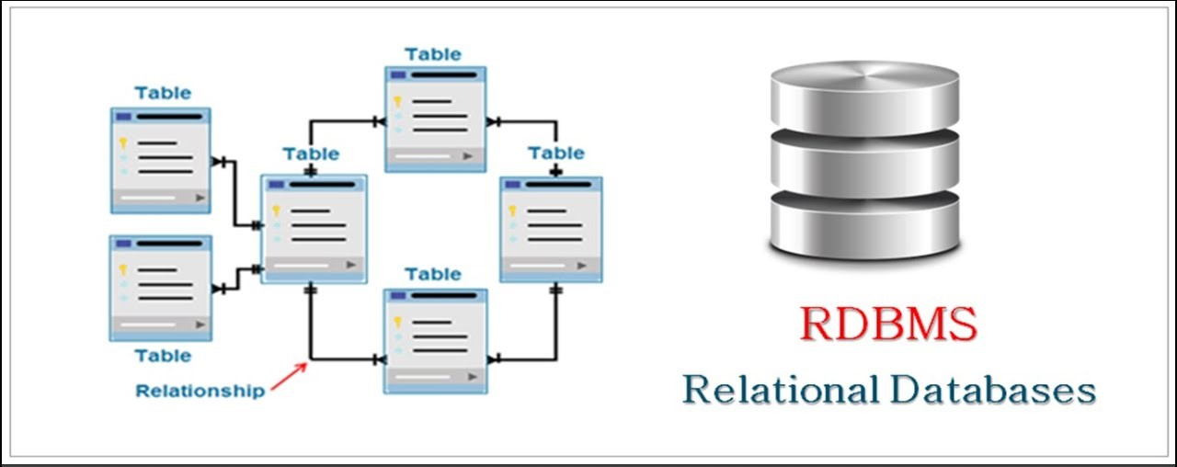

Fig-1.1 RDMS Table

- Determines the database schema and tables required to store the system's data.

- Defines the relationships between the tables and establishes the appropriate data normalization.

- Considers data integrity, performance, and scalability while designing the database.

4. User Interface Design:

- Specifies the visual design and layout of the user interface.

- Considers usability principles to create an intuitive and user-friendly interface.

- Defines the navigation flow and interactions between different screens or pages.

5. Security Design:

- Addresses the security requirements of the Tender Management System.

- Defines access control mechanisms, authentication, and authorization processes.

- Considers data encryption, secure communication, and protection against vulnerabilities.

6. Integration Design:

- Specifies the integration points with external systems or services.

- Defines the protocols, APIs, or web services for data exchange.

- Considers error handling, data validation, and synchronization mechanisms.

7. Deployment Design:

- Determines the deployment strategy and environment for the system.

- Considers the hardware, software, and network infrastructure required.

- Defines the system's scalability, availability, and performance considerations.

Chapter 4: System Design

4.2 Database Design

The database design phase focuses on creating an efficient and well-structured database for the Tender Management System. This section outlines the key components and cosiderations involved in the database design process.

1. Conceptual Design:

- Identifies the main entities and their relationships in the system.

- Represents the entities and their relationships using an Entity-Relationship (ER) diagram.

- Defines the attributes and primary keys for each entity.

2. Logical Design:

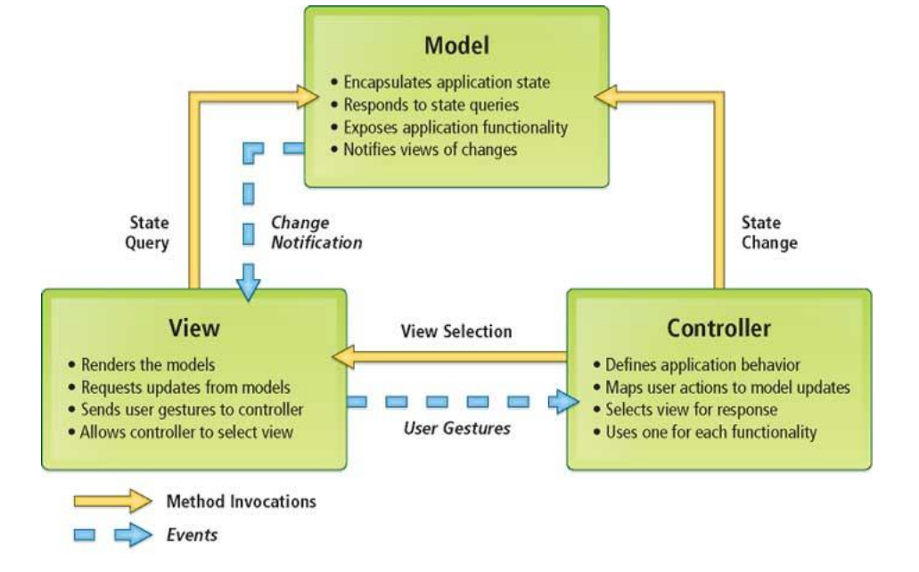

Fig-1.2 MVC Project designing Flow Chart

- Transforms the conceptual design into a logical database model.

- Specifies the tables, columns, and data types for each entity.

- Establishes the relationships between tables using foreign keys.

- Considers data normalization to minimize redundancy and ensure data integrity.

3. Physical Design:

- Determines the physical implementation of the database.

- Considers factors such as storage capacity, performance, and security.

- Defines indexes, partitions, and other optimizations to enhance query performance.

- Chooses an appropriate database management system (DBMS) like MySQL, Oracle, or PostgreSQL.

4. Data Integrity:

- Ensures data integrity by applying constraints and rules to the database.

- Defines primary keys, unique constraints, and foreign key constraints.

- Implements validation rules and triggers to enforce data consistency.

5. Data Access and Manipulation:

- Defines the methods and queries required for data access and manipulation.

- Considers the system's functional requirements to determine the necessary CRUD (Create, Read, Update, Delete) operations.

- Considers data security and implements appropriate access control mechanisms.

6. Backup and Recovery:

- Establishes a backup and recovery strategy for the database.

- Defines regular backup schedules and retention policies.

- Implements mechanisms for restoring the database in case of data loss or system failures.

7. Performance Optimization:

- Analyzes the system's performance requirements and identifies potential bottlenecks.

- Optimizes database performance through techniques such as indexing, query optimization, and caching.

- Considers database scalability and implements strategies to handle increasing data volumes.

The database design plays a crucial role in ensuring efficient data storage, retrieval, and management in the Tender Management System. It provides a solid foundation for the system's functionality, performance, and data integrity. A well-designed database enhances system reliability, facilitates data analysis, and supports the system's long-term scalability and maintainability.

Chapter 4: System Design

4.3 User Interface Design

The user interface design phase focuses on creating an intuitive and user-friendly interface for the Tender Management System. This section outlines the key components and considerations involved in designing the user interface.

1. User Interface Requirements:

- Identifies the target users of the system and their needs.

- Defines the functional and non-functional requirements for the user interface.

- Considers factors such as usability, accessibility, and responsiveness.

2. Wireframing:

5. Input and Interaction Design:

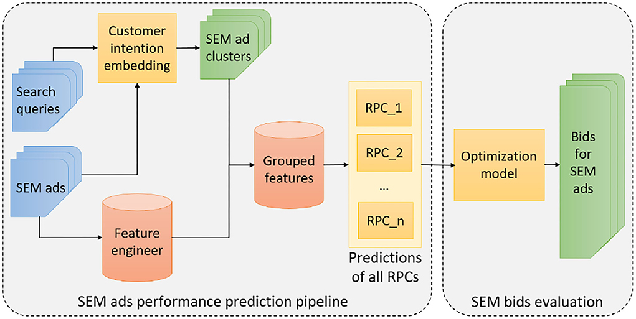

Fig 1.3 : SEM bids Evluation

- Determines how users input data and interact with the system.

- Designs forms, input fields, dropdowns, checkboxes, and other input elements.

- Considers validation rules, error handling, and feedback mechanisms.

6. Information Display:

- Defines how information is presented to users.

- Determines the layout of data tables, lists, and cards.

- Considers data visualization techniques, such as charts or graphs, for presenting complex data.

7. Responsiveness and Adaptability:

- Designs the user interface to be responsive and adaptable to different devices and screen sizes.

- Considers the use of responsive design frameworks or techniques.

- Ensures that the interface functions well on desktops, tablets, and mobile devices.

8. Usability Testing:

- Conducts usability testing with representative users to evaluate the effectiveness and efficiency of the user interface.

- Collects feedback and iterates on the design to improve usability and user satisfaction.

The user interface design is crucial in creating an engaging and efficient user experience for the Tender Management System. It aims to simplify user interactions, guide users through tasks, and provide clear and meaningful feedback. A well-designed user interface enhances user productivity, reduces errors, and promotes user adoption and satisfaction.

Chapter 4: System Design

4.4 Integration Design

The integration design phase focuses on defining how the Tender Management System interacts and integrates with external systems or services. This section outlines the key components and considerations involved in designing the system's integration.

1. Integration Requirements:

- Identifies the integration needs and requirements of the Tender Management System.

- Determines the types of integration, such as data integration, API integration, or service integration.

- Considers the goals and benefits of integrating with external systems or services.

2. Interface Definition:

- Defines the interfaces between the Tender Management System and external systems.

- Specifies the protocols, data formats, and communication methods for data exchange.

- Considers standards and conventions for seamless integration.

3. Data Integration:

- Determines the data integration requirements.

- Defines the data mappings and transformations between systems.

- Considers data validation, data synchronization, and data consistency across systems.

4. API Integration:

- Identifies the external APIs (Application Programming Interfaces) required for integration.

- Defines the API endpoints, authentication mechanisms, and data formats.

- Considers API versioning, error handling, and rate limiting.

5. Service Integration:

- Specifies the integration with external services or microservices.

- Identifies the service dependencies and interactions.

- Considers service discovery, load balancing, and fault tolerance.

6. Error Handling and Exception Management:

- Defines error handling mechanisms for integration scenarios.

- Considers handling exceptions, timeouts, and retries.

- Implements logging and monitoring for identifying integration failures.

7. Security and Authentication:

- Implements secure authentication and authorization mechanisms for integration.

- Considers secure communication channels and access control for external systems.

- Ensures the confidentiality and integrity of data during integration.

8. Testing and Validation:

- Performs integration testing to validate the functionality and reliability of the integrated system.

- Conducts end-to-end testing to ensure seamless data flow and system interoperability.

- Validates data accuracy and consistency across integrated systems.

The integration design ensures that the Tender Management System seamlessly interacts with external systems or services, enabling data exchange, process automation, and system interoperability. It aims to establish reliable and efficient integration channels, ensuring that the system can leverage the capabilities of external systems or services while maintaining data integrity and security.

Chapter 4: System Design

4.5 Security Design

The security design phase focuses on identifying and implementing measures to ensure the security and protection of the Tender Management System and its data. This section outlines the key components and considerations involved in designing the system's security.

1. Threat Analysis:

- Identifies potential threats and risks to the system's security.

- Conducts a thorough analysis of vulnerabilities and potential attack vectors.

- Considers both external and internal threats, such as unauthorized access, data breaches, and malicious activities.

2. Access Control:

- Defines access control mechanisms to restrict system access based on user roles and privileges.

- Implements authentication mechanisms to verify the identity of users.

- Establishes authorization rules to control the actions and data that users can access.

3. Data Protection:

- Implements mechanisms to protect the confidentiality, integrity, and availability of sensitive data.

- Utilizes encryption techniques to secure data in transit and at rest.

- Implements data masking or anonymization for sensitive data as necessary.

4. Security Testing:

- Conducts security testing to identify vulnerabilities and weaknesses in the system.

- Performs penetration testing, vulnerability scanning, and code review to identify potential security risks.

- Fixes any identified vulnerabilities and applies security patches and updates.

5. Secure Communication:

- Ensures secure communication between the system components and external entities.

- Utilizes secure protocols such as HTTPS for web communication.

- Implements mechanisms to prevent man-in-the-middle attacks and data tampering.

6. Audit and Logging:

- Implements logging mechanisms to capture system activities and events.

- Monitors and analyzes logs for potential security incidents.

- Maintains an audit trail for accountability and forensic purposes.

7. Incident Response:

- Defines an incident response plan to handle security incidents.

- Establishes procedures for detecting, responding to, and recovering from security breaches or incidents.

- Trains system administrators and relevant personnel on incident response protocols.

8. Compliance and Regulations:

- Ensures compliance with relevant security standards, regulations, and industry best practices.

- Considers data privacy regulations, such as GDPR or HIPAA, if applicable.

- Performs regular security audits to maintain compliance.

The security design is crucial in safeguarding the Tender Management System and protecting sensitive data from unauthorized access, breaches, and malicious activities. By implementing robust security measures, the system can provide a secure environment for users and maintain the confidentiality, integrity, and availability of the system's data.

Chapter 5: System Implementation

5.1 Implementation Overview

The implementation phase focuses on translating the design specifications of the Tender Management System into a functional system. This section provides an overview of the implementation process and highlights key considerations.

1. Development Environment:

- Set up the development environment with the necessary tools and technologies.

- Install and configure the required software, such as an Integrated Development Environment (IDE), web server, and database management system.

2. Coding and Programming:

- Write the code for the different components and modules of the Tender Management System.

- Follow coding best practices and coding standards to ensure maintainability and readability of the code.

- Implement the business logic, data access layer, user interface, and integration points according to the system's design.

3. Database Implementation:

- Create the database schema based on the database design specifications.

- Implement the tables, columns, indexes, and relationships defined in the database design.

- Populate the database with sample or test data as required.

4. User Interface Implementation:

- Develop the user interface components based on the user interface design specifications.

- Use appropriate technologies such as HTML, CSS, JavaScript, and front-end frameworks.

- Ensure the user interface is responsive, accessible, and compatible with different browsers and devices.

5. Integration Implementation:

- Implement the necessary integrations with external systems or services.

- Develop the API endpoints or integration points as defined in the integration design.

- Handle data exchange, authentication, and error handling in the integration processes.

6. Testing and Debugging:

- Conduct unit testing to verify the correctness of individual components and modules.

- Perform integration testing to ensure the proper functioning of the system as a whole.

- Identify and debug any issues or defects in the code and fix them.

7. System Documentation:

- Document the implementation details, including code documentation, database schema, and configuration settings.

- Create user manuals or system documentation to guide users on how to use the system effectively.

- Document any dependencies, installation instructions, and system requirements.

8. Deployment:

- Prepare the system for deployment in the production environment.

- Configure the necessary servers, networks, and security settings for hosting the system.

- Deploy the system and ensure its proper functioning in the production environment.

The implementation phase is a critical step in bringing the Tender Management System to life. It involves translating the design specifications into functional code, implementing the database, developing the user interface, integrating with external systems, and ensuring the system's reliability and performance through testing and debugging. Proper documentation and deployment processes are essential to facilitate system maintenance and support in the future.

Chapter 5: System Implementation

5.2 Testing and Quality Assurance

The testing and quality assurance phase is an essential part of the system implementation process for the Tender Management System. This section outlines the key aspects and considerations involved in testing and ensuring the quality of the system.

1. Test Planning:

- Define the testing objectives and scope.

- Identify the test scenarios and use cases based on system requirements.

- Determine the test data and test environment requirements.

2. Test Case Development:

- Create test cases to cover various system functionalities.

- Specify the expected results for each test case.

- Consider both positive and negative test scenarios to ensure comprehensive coverage.

3. Unit Testing:

- Conduct unit testing to verify the correctness of individual components or modules.

- Test each unit in isolation to ensure that it functions as expected.

- Use appropriate testing frameworks and tools to automate unit tests where possible.

4. Integration Testing:

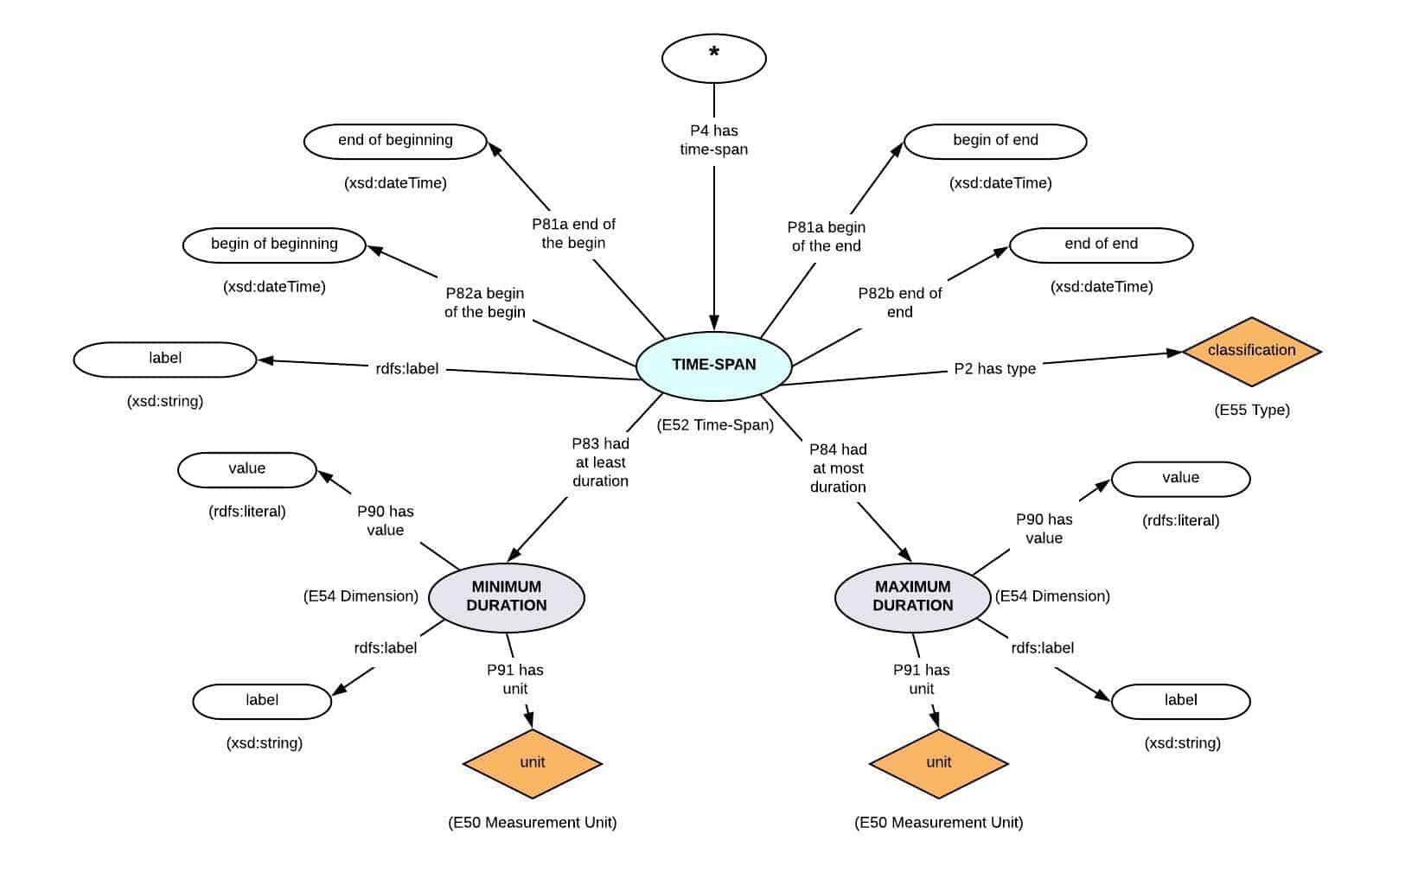

Fig 1.4 : Measurment Units

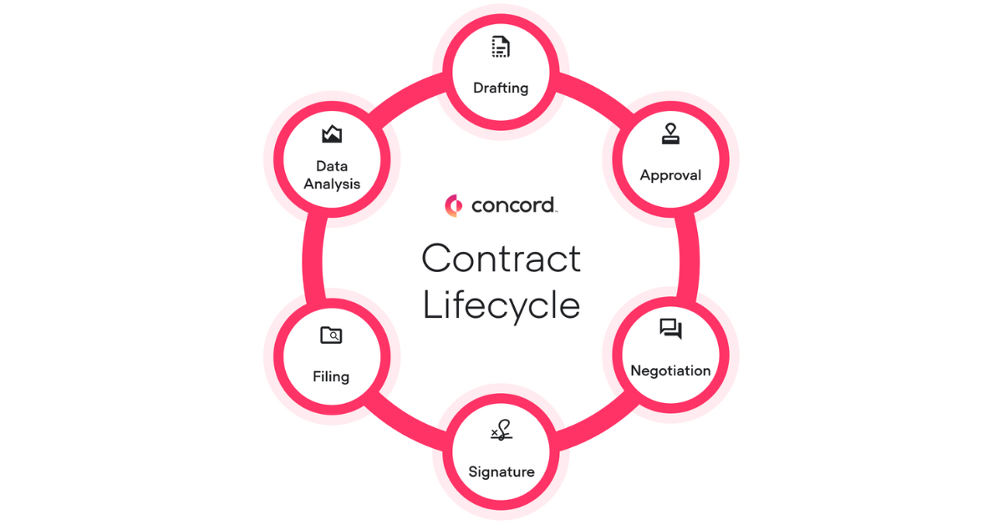

Fig 1.5: Contract Lifecycle

10. Quality Assurance:

- Ensure that the system meets the desired quality standards.

- Conduct code reviews and inspections to identify potential coding issues or violations.

- Implement quality control measures to improve code readability, maintainability, and performance.

The testing and quality assurance phase is crucial in ensuring that the Tender Management System is reliable, functional, and meets the specified requirements. By following a systematic testing approach and addressing identified issues, the system's overall quality and performance can be improved, leading to a more successful implementation and user satisfaction.

Chapter 5: System Implementation

5.3 Deployment and Maintenance

The deployment and maintenance phase involves the release and installation of the Tender Management System in the production environment, as well as ongoing support and maintenance activities. This section highlights key considerations and processes involved in deploying and maintaining the system.

1. Deployment Planning:

- Define the deployment strategy, including the deployment schedule and rollout plan.

- Identify the target production environment and infrastructure requirements.

- Plan for data migration, if applicable, to transfer any existing data to the production system.

2. Production Environment Setup:

- Prepare the production environment by configuring the necessary servers, networks, and security settings.

- Install and configure the web server, application server, and database server.

- Set up monitoring tools and establish system performance metrics.

3. System Installation:

- Deploy the Tender Management System to the production environment.

- Install and configure the system components, including the application code, database schema, and any required third-party libraries or dependencies.

- Perform necessary configurations, such as setting up system parameters and connection settings.

4. Data Migration:

- If applicable, migrate any existing data from the previous system or sources to the production database.

- Ensure data integrity and accuracy during the migration process.

- Perform data validation and reconciliation to ensure the successful transfer of data.

5. System Monitoring and Maintenance:

- Set up monitoring tools to monitor the system's performance, availability, and resource usage.

- Monitor system logs, error reports, and user feedback to identify and address any issues or bugs.

- Regularly maintain and optimize the system, including database optimization, code refactoring, and performance tuning.

6. User Training and Support:

- Provide training sessions or materials to users to familiarize them with the Tender Management System.

- Offer user support channels, such as a helpdesk or knowledge base, to assist users with system-related queries and issues.

- Continuously gather user feedback and suggestions for system improvements.

7. System Updates and Upgrades:

- Plan and implement system updates and upgrades to introduce new features, enhancements, or bug fixes.

- Test updates in a staging or test environment before applying them to the production system.

- Communicate updates and changes to users and provide any necessary documentation or training.

8. Incident Management and Troubleshooting:

- Establish incident management procedures to handle system failures, errors, or disruptions.

- Monitor system alerts and respond promptly to resolve any incidents.

- Conduct root cause analysis to identify the underlying causes of incidents and implement preventive measures.

9. Backup and Disaster Recovery:

- Set up regular backup routines to ensure data protection and recovery options in case of data loss or system failures.

- Test and validate the backup and disaster recovery procedures to ensure their effectiveness.

- Store backups securely and off-site to mitigate risks of data loss.

The deployment and maintenance phase is crucial for ensuring the successful operation and longevity of the Tender Management System. By following proper deployment procedures, monitoring system performance, providing user support, and addressing maintenance tasks, the system can deliver the intended functionality and continue to meet the needs of its users over time.

Chapter 5: System Implementation

5.4 Documentation and User Manuals

Documentation and user manuals play a crucial role in facilitating the understanding, adoption, and effective usage of the Tender Management System. This section focuses on the importance of documentation and provides an overview of the key components of system documentation.

1. System Documentation Purpose:

- Explain the purpose and benefits of system documentation.

- Ensure that the system's functionalities, features, and workflows are well-documented.

- Provide a reference guide for system administrators, developers, and end users.

2. User Manuals:

- Develop user manuals that guide end users on how to interact with the Tender Management System.

- Provide step-by-step instructions for common tasks, such as creating a tender, managing bids, and generating reports.

- Include screenshots, diagrams, and examples to enhance clarity and understanding.

3. Installation Guide:

- Create an installation guide that outlines the steps to install and configure the system.

- Specify the system requirements, including hardware, software, and database prerequisites.

- Provide detailed instructions for setting up the development and production environments.

4. Configuration Guide:

- Document the configuration options and settings of the Tender Management System.

- Explain the purpose and impact of each configuration parameter.

- Provide guidelines and best practices for configuring the system based on specific use cases or requirements.

5. API Documentation:

- If the system offers APIs (Application Programming Interfaces) for integration purposes, document the APIs comprehensively.

- Describe the available endpoints, request and response formats, authentication mechanisms, and error handling.

- Provide code samples or SDKs (Software Development Kits) to assist developers in using the APIs effectively.

6. Database Documentation:

- Document the database schema and structure of the Tender Management System.

- Include descriptions of tables, fields, relationships, and constraints.

- Explain the purpose and usage of each database entity.

7. System Architecture Documentation:

- Describe the overall architecture of the Tender Management System.

- Document the various components, modules, and their interactions.

- Provide diagrams, such as high-level architecture diagrams or component diagrams, to illustrate the system's structure.

8. Release Notes:

- Prepare release notes for each system version or update.

- List the new features, enhancements, bug fixes, and known issues.

- Communicate the release notes to users and stakeholders to keep them informed of system changes.

9. Troubleshooting and FAQ:

- Compile a troubleshooting guide that addresses common issues and their solutions.

- Include a Frequently Asked Questions (FAQ) section to provide quick answers to common queries.

- Update the troubleshooting guide and FAQ based on user feedback and support interactions.

Effective documentation enables users to understand the system's capabilities, functionalities, and usage, leading to better adoption and utilization of the Tender Management System. It serves as a valuable resource for system administrators, developers, and end users, empowering them to navigate the system confidently and troubleshoot issues effectively.

Chapter 6: System Testing and Evaluation

6.1 Test Plan Creation and Formulation of Test Cases

During the system testing and evaluation phase, it is crucial to create a comprehensive test plan and formulate test cases to ensure the Tender Management System functions as intended. This section focuses on the process of test plan creation and the formulation of test cases.

1. Test Plan Creation:

- Define the objectives and scope of the testing phase.

- Identify the different types of testing to be performed, such as functional testing, performance testing, security testing, and usability testing.

- Determine the testing approach, including whether manual testing, automated testing, or a combination of both will be used.

- Specify the testing resources, including the test environment, test data, and testing tools.

2. Test Strategy:

- Determine the overall approach and techniques to be used in testing.

- Define the testing priorities and sequencing of different test types.

- Identify the risk areas and critical functionalities that require special attention during testing.

- Consider factors such as time constraints, budget limitations, and available resources.

3. Test Case Formulation:

- Identify the different features, functionalities, and scenarios to be tested.

- Formulate test cases that cover all possible combinations and variations of inputs and expected outputs.

- Ensure that each test case is clear, concise, and specific, with a defined set of preconditions, inputs, expected results, and post-conditions.

- Include both positive and negative test cases to validate the system's behavior under different conditions.

4. Test Data Preparation:

- Prepare the necessary test data to simulate real-world scenarios.

- Ensure that the test data represents a wide range of inputs, including valid and invalid data, boundary values, and edge cases.

- Create data sets that cover different user roles, system configurations, and use case scenarios.

5. Test Execution and Tracking:

- Execute the formulated test cases based on the test plan.

- Document the actual results, including any deviations or discrepancies from the expected results.

- Track the status of each test case, indicating whether it passed, failed, or requires further investigation or retesting.

- Utilize test management tools or spreadsheets to organize and track the progress of testing activities.

6. Defect Reporting and Management:

- Report any identified defects or issues in a systematic manner.

- Document the steps to reproduce the defect, including the test case and test data used.

- Classify and prioritize the defects based on their severity and impact on the system's functionality.

- Coordinate with the development team to ensure timely resolution and retesting of the defects.

7. Test Coverage Analysis:

- Evaluate the test coverage to ensure that all critical functionalities and system components are adequately tested.

- Identify any gaps in the test coverage and formulate additional test cases if necessary.

- Use coverage analysis tools to measure the extent of code coverage, requirements coverage, or other relevant coverage metrics.

8. Test Result Analysis and Reporting:

- Analyze the test results to assess the system's performance, stability, and compliance with the defined requirements.

- Identify patterns or trends in the test results and address any recurring issues or failures.

- Prepare comprehensive test reports, summarizing the testing activities, results, and any recommendations for further improvements.

By creating a well-defined test plan and formulating effective test cases, the Tender Management System can be thoroughly tested to identify any defects, ensure its functionality, and validate its adherence to the specified requirements. Proper test planning and execution contribute to the overall quality and reliability of the system, providing stakeholders with confidence in its performance and usability.

Chapter 6: System Testing and Evaluation

6.2 Conducting Unit Testing to Verify Individual Components

Unit testing is a crucial part of the system testing and evaluation phase, specifically focused on verifying the functionality and correctness of individual components in the Tender Management System. This section highlights the importance of unit testing and provides an overview of the process involved.

1. Unit Testing Purpose:

- Verify the behavior of individual components, such as classes, methods, or functions, in isolation.

- Identify defects or errors at an early stage, allowing for prompt debugging and resolution.

- Ensure that each component functions as intended and adheres to the specified requirements.

2. Testable Units:

- Identify the testable units within the Tender Management System, such as classes, modules, or libraries.

- Break down the system into smaller, manageable components for unit testing.

- Consider factors such as complexity, dependencies, and criticality when selecting units for testing.

3. Test Case Formulation:

- Create test cases that target specific functionality or behavior of each unit.

- Define input values, expected outputs, and any preconditions or dependencies required for testing.

- Cover different scenarios, edge cases, and boundary conditions to ensure comprehensive coverage.

- Include both positive and negative test cases to validate correct behavior and error handling.

4. Test Environment Setup:

- Set up a controlled test environment for unit testing.

- Use test doubles, such as stubs or mocks, to isolate the unit under test from its dependencies.

- Provide necessary resources, test data, and configurations required for accurate unit testing.

5. Test Execution:

- Execute the unit tests for each testable unit, following the defined test cases.

- Invoke the component with the specified inputs and evaluate the actual outputs against the expected results.

- Capture any exceptions, errors, or failures encountered during the unit test execution.

- Log relevant information, such as test execution time or any diagnostic data, for further analysis.

6. Assertion and Validation:

- Utilize assertions or validation techniques to check the correctness of the unit's outputs.

- Compare actual results with expected results and report any discrepancies.

- Verify that the unit adheres to the defined business rules, constraints, or algorithms.

7. Test Coverage Analysis:

- Measure the coverage achieved through unit testing.

- Assess the extent to which the test cases exercise the code and functionality of each unit.

- Analyze coverage metrics, such as statement coverage, branch coverage, or path coverage.

- Identify any gaps in coverage and create additional test cases if necessary.

8. Test Result Analysis and Reporting:

- Analyze the test results and identify any failures or deviations from the expected behavior.

- Debug and diagnose the root causes of failures, using logging, debugging tools, or other diagnostic techniques.

Chapter 6: System Testing and Evaluation

6.3 Integration Testing

Integration testing is a crucial part of the system testing and evaluation phase that focuses on testing the interaction and collaboration between different components or modules of the Tender Management System. This section highlights the importance of integration testing and provides an overview of the process involved.

1. Integration Testing Purpose:

- Verify the proper functioning and interaction between different components or modules.

- Identify any integration issues, such as communication failures, data inconsistencies, or compatibility problems.

- Ensure that the integrated system functions as a cohesive unit and meets the specified requirements.

2. Integration Test Environment Setup:

- Set up a dedicated integration test environment that mirrors the production environment as closely as possible.

- Configure and deploy all the necessary components, modules, and dependencies required for integration testing.

- Prepare representative test data that covers various scenarios and real-world usage patterns.

3. Integration Test Case Formulation:

- Define integration test cases that focus on testing the interactions between different components.

- Identify the input data, expected outputs, and any preconditions or dependencies for each test case.

- Cover different integration scenarios, data flows, and communication protocols.

4. Integration Test Execution:

- Execute the integration test cases in a systematic and controlled manner.

- Validate the interactions and interfaces between components.

- Monitor and analyze the data flow and communication between the integrated components.

- Capture and log any errors, exceptions, or failures encountered during the integration testing.

5. Data Consistency and Integrity:

- Verify the consistency and integrity of data exchanged between integrated components.

- Ensure that data transformations, validations, and mappings are performed correctly.

- Validate that data synchronization and updates are propagated accurately across the system.

6.4 User Acceptance Testing

User acceptance testing (UAT) is a critical phase of system testing that involves engaging end-users to validate and provide feedback on the Tender Management System. This section highlights the importance of UAT and outlines the process involved.

1. UAT Purpose:

- Ensure that the Tender Management System meets the needs and expectations of end-users.

6.5 : Performance Evaluation

- Measure the system's response time, throughput, resource utilization, and scalability under different loads and scenarios.

- Identify any performance bottlenecks, latency issues, or scalability limitations.

- Ezsure that the system can handle the expected workload and meet the performance requirements.

2. Performance Test Planning:

- Define the performance test objectives, scope, and success criteria.

- Identify the performance metrics to be measured, such as response time, throughput, or concurrent user capacity.

- Determine the test scenarios, workload profiles, and test data to be used during performance testing.

- Set up performance monitoring and profiling tools to capture relevant performance metrics.

3. Performance Test Execution:

- Execute the performance tests by simulating realistic user loads and usage patterns.

- Monitor and measure key performance metrics, such as response time, CPU usage, memory consumption, and network traffic.

- Analyze system behavior under different load levels and identify any performance issues or bottlenecks.

- Capture and log performance data for further analysis and comparison against performance targets.

4. Performance Test Analysis:

- Analyze the collected performance data to identify performance bottlenecks and areas for improvement.

- Use performance profiling tools and techniques to pinpoint the root causes of performance issues.

- Evaluate system scalability by gradually increasing the load and observing the system's response.

- Compare the performance results against predefined performance targets or benchmarks.

5. Performance Test Reporting:

- Document the performance test results, including performance metrics, observations, and identified issues.

- Summarize the system's performance characteristics and provide recommendations for performance optimization.

- Communicate the performance evaluation findings and recommendations to the development team and stakeholders.

- Collaborate with the development team to implement performance improvements or optimizations.

Chapter 7: Results and Discussion

7.1 Evaluation of System Functionality and Adherence to Requirements

In this section, the evaluation of the Tender Management System's functionality and its adherence to the specified requirements is presented. The system's features and capabilities are assessed against the defined functional requirements to determine whether they have been successfully implemented.

1. Functional Requirements Evaluation:

- Review each functional requirement defined for the Tender Management System.

- Assess the system's functionality and determine whether it meets the requirements.

- Identify any gaps or deviations from the intended functionality.

2. Adherence to Non-Functional Requirements:

- Evaluate the system's compliance with non-functional requirements, such as performance, security, and scalability.

- Assess the system's response time, throughput, and resource utilization against the specified performance requirements.

- Verify that the system incorporates appropriate security measures to protect sensitive data and ensure user privacy.

3. Validation of Business Rules and Logic:

- Validate the implementation of business rules and logic within the Tender Management System.

- Verify that the system correctly enforces rules and constraints related to tender submission, evaluation, and selection processes.

4. Results and Analysis:

- Summarize the evaluation results, highlighting the system's strengths and areas of improvement.

- Discuss any significant findings, successes, or challenges encountered during the evaluation process.

- Provide a detailed analysis of the system's functionality and its alignment with the requirements.

- Identify any potential gaps or shortcomings that may require further attention or enhancements.

7.2 Assessment of User Experience and System Usability

This section focuses on the assessment of the Tender Management System's user experience (UX) and usability. It involves evaluating the system's user interface, navigation, and overall user satisfaction.

1. User Interface Evaluation:

- Assess the visual design and layout of the user interface (UI) for aesthetics and consistency.

- Evaluate the usability of UI components, such as forms, buttons, menus, and navigation elements.

2. Navigation and Interaction Evaluation:

- Evaluate the ease of navigation within the Tender Management System.

- Assess the intuitiveness and efficiency of user interactions, such as searching, filtering, and sorting functionalities.

3. User Satisfaction Assessment:

- Collect feedback from end-users regarding their overall satisfaction with the Tender Management System.

- Use surveys, interviews, or user feedback sessions to gather qualitative and quantitative data.

4. Results and Analysis:

- Summarize the assessment results, highlighting the system's strengths and areas for improvement in terms of user experience and usability.

- Discuss any user feedback or suggestions for enhancing the system's usability.

7.3 Comparison with Existing Tender Management Systems

Tender Management System with existing systems available in the market or in use within organizations. The goal is to evaluate the uniqueness, advantages, and potential drawbacks of the developed system in comparison to its competitors.

1. Identification of Existing Tender Management Systems:

- Research and identify existing tender management systems that are widely used or recognized in the industry.

- Analyze their features, functionalities, and capabilities.

2. Comparison Criteria:

- Define criteria for the comparison, such as system features, user interface, scalability, performance, and cost.

- Determine the importance of each criterion based on user requirements and industry standards.

3. System Comparison:

- Compare the developed Tender Management System with the identified existing systems based on the defined criteria.

- Assess how the developed system performs in terms of features, usability, performance, and other relevant aspects.

- Identify the unique selling points and advantages of the developed system over its competitors.

- Analyze any areas where the developed system may lag behind existing systems and provide suggestions for improvement.

4. Results and Analysis:

- Summarize the comparison results, highlighting the strengths and weaknesses of the developed Tender Management System in comparison to existing systems.

- Discuss the competitive advantages of the developed system and its potential market positioning.

- Identify opportunities for further enhancements or differentiation to make the system more competitive.

7.4 Identification of Limitations and Suggestions for Future Enhancements

In this section, the limitations of the developed Tender Management System are identified and discussed. Additionally, suggestions for future enhancements and improvements are provided to address these limitations and further enhance the system's capabilities.

1. Identification of Limitations:

- Evaluate the Tender Management System to identify any limitations or shortcomings.

- Consider factors such as functionality, performance, usability, security, and scalability.

- Identify areas where the system may not fully meet user requirements or industry standards.

2. Limitations Analysis:

- Analyze the impact of the identified limitations on the system's functionality, user experience, and overall performance.

- Discuss the implications of these limitations on the system's effectiveness and user satisfaction.

3. Suggestions for Future Enhancements:

- Provide recommendations for addressing the identified limitations and improving the system's capabilities.

- Propose specific enhancements or features that can be implemented to overcome the limitations.

- Consider industry trends, emerging technologies, and user feedback when suggesting enhancements.

- Discuss the potential benefits of these enhancements and their impact on the system's effectiveness.

- Recap the evaluation process conducted to validate the system's functionality, usability, and adherence to requirements.

- Discuss the positive evaluation results and the system's performance in meeting the specified criteria.

- Emphasize the value and reliability of the developed system.

8.2 Contributions to Knowledge in the Field of Tender Management

In this section, the contributions made by the research and development of the Tender Management System to the field of tender management are discussed. These contributions may include innovative features, improved processes, or insights gained from the development process.

1. Advancements in Tender Management:

- Discuss the innovative features or functionalities introduced in the developed system that contribute to improving the tender management process.

- Highlight any novel approaches or techniques applied during the system development that can enhance efficiency, effectiveness, or transparency in managing tenders.

2. Addressing Existing Challenges:

- Identify and discuss the challenges or limitations existing in traditional tender management systems.

- Explain how the developed Tender Management System overcomes these challenges or improves upon existing solutions.

- Emphasize the practical significance and relevance of the developed system in addressing real-world tender management issues.

8.3 Recommendations for Future Research and System Improvements

In this section, recommendations for future research and potential improvements to the Tender Management System are provided. These recommendations aim to enhance the system's functionality, user experience, and overall performance.

1. Future Research Directions:

- Identify areas within the field of tender management that warrant further research.

- Suggest potential research topics or areas of investigation that can extend the knowledge and understanding of tender management practices.

- Discuss how future research can contribute to the ongoing development and improvement of tender management systems.

2. System Improvements:

- Based on the evaluation and user feedback, provide recommendations for system enhancements and refinements.

- Discuss specific areas or functionalities that can be improved to address identified limitations or user needs.

- Propose ideas for incorporating emerging technologies or industry best practices to enhance the system's capabilities.

Chapter 9: References

In this section, provide a list of properly cited sources that were used throughout the thesis. The references should include academic papers, research articles, books, websites, and any other relevant sources consulted during the research and development of the Tender Management System. Follow the appropriate citation style guidelines (e.g., APA, MLA, IEEE) for formatting the references.

Note: Ensure that all sources are accurately cited and properly formatted to maintain academic integrity and give credit to the original authors.

By concluding the thesis with a summary of achievements, contributions to knowledge, recommendations for future research and system improvements, and a comprehensive list of properly cited references, a well-rounded conclusion can be provided that highlights the significance of the research and the developed Tender Management System in the field of tender management.

Appendix A: Use Case Diagrams

This appendix presents the use case diagrams that illustrate the various functionalities and interactions of the Tender Management System. Use case diagrams provide a visual representation of the system's actors, use cases, and their relationships, helping to understand the system's behavior and requirements.

Appendix B: Entity-Relationship Diagrams

In this appendix, the entity-relationship diagrams (ER diagrams) for data modeling in the Tender Management System are provided. The ER diagrams depict the entities, their attributes, and the relationships between them. These diagrams help in understanding the structure of the database and the data flow within the system.

Appendix C: Data Flow Diagrams

This appendix includes the data flow diagrams (DFDs) that illustrate the flow of data within the Tender Management System. The DFDs show the processes, data stores, external entities, and data flows in the system, helping to visualize how data is processed and transformed throughout the system.

Appendix D: Source Code Snippets

In this appendix, selected source code snippets from the implementation of the Tender Management System are presented. The code snippets demonstrate key functionalities or algorithms used in the system's development. These code snippets serve as a reference and provide insights into the programming techniques employed in the system.

Appendix E: Test Cases and Results

This appendix contains the test cases formulated for the Tender Management System and the corresponding test results. The test cases cover various scenarios and functionalities of the system, ensuring that it functions as intended. The results document the outcomes of the tests, including any discrepancies or issues encountered during testing.

Appendix F: User Feedback Forms or Surveys

**DATA FLOW DIAGRAMS**

**INTRODUCTION:**

           The system specification is produced at the culmination of the analysis task.  The function and Performance allocated the software as part of the system engineering are refined by the established a complete information of performance requirements and design constraints, appropriate validation criteria, and others data pertaining to requirements. The tools that are used in this system analysis are data flow diagram and data dictionary.

**DATA FLOW DIAGRAMS:**

A Data Flow Diagram (DFD) is a graphical technique that depicts information flow and the transforms that are applied as data move from input to output.

            Data flow diagram is a logical model of a system. The model does not depend on hardware, software, and data structure or file organization. It only shows the data flow between modules to module of the entire system. Data flow diagrams can be completed using only four notations as follows,

Data Flow Diagrams are of two types:

1. **Physical Data Flow Diagrams**:  These are implementation-dependent i.e.,    they show the actual devices, departments, people, etc., involved in the system.
2. **Logical Data Flow Diagrams**: These diagrams describe the system independently of how it is actually implemented, they show what takes places, rather than how an activity is accomplished.

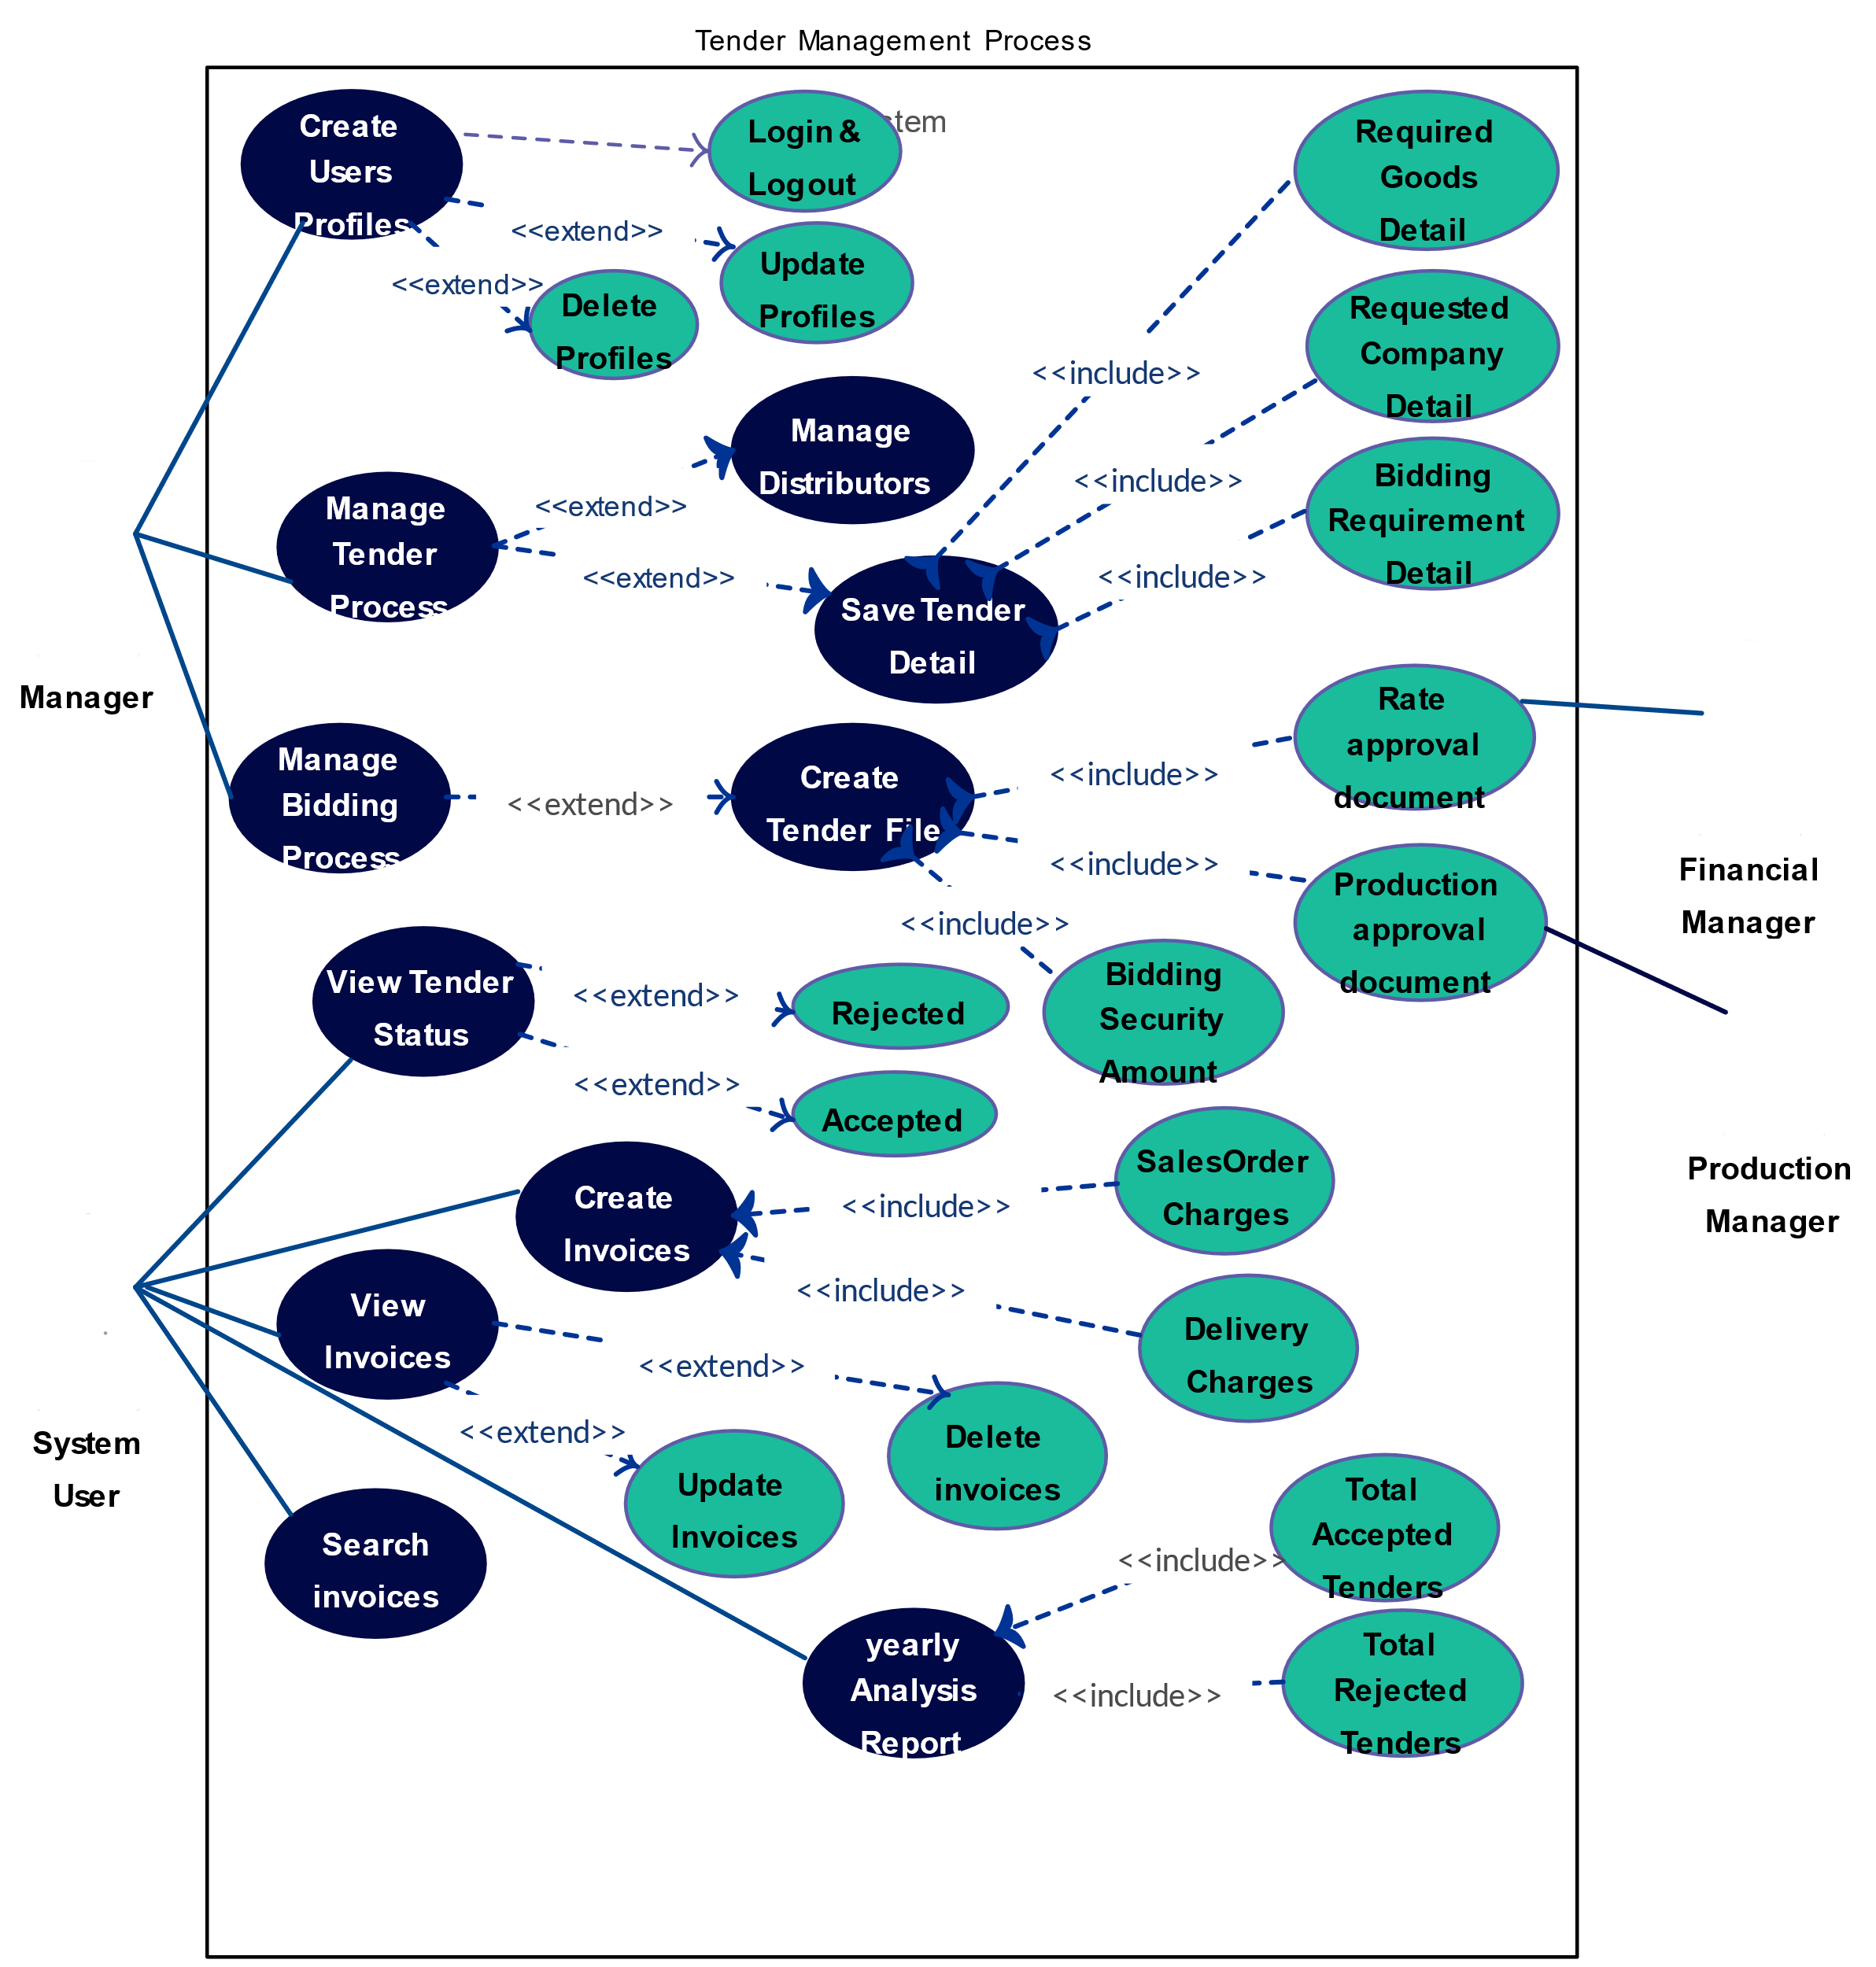

Fig- 1.6 UML Diagram Of Tender Management System

**Sequence Diagrams:-**

**Supplier Login:**

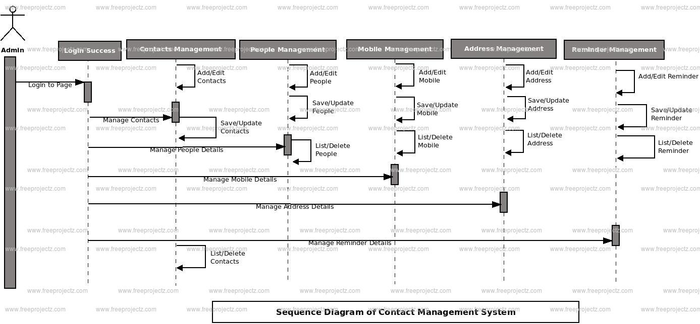

Fig 1.7 : Supplier Login Diagram for contact Management System

**HARDWARE AND SOFTWARE REQUIREMENTS**

**Hard Ware Requirements:-**

* **Processor:: Pentium-II(or) Higher**
* **Ram:: 512MB (or) Higher**
* **Cache:: 512MB**
* **Hard disk:: 10GB**

**Soft Ware Requirements:-**

|  |  |  |
| --- | --- | --- |
| * **Web Server** | **:** | **Tomcat 5.5** |
| * **Server-side Technologies** | **:** | **Java, Java Server Pages** |
| * **Client-side Technologies** | **:** | **Hyper Text Markup Language, Cascading Style Sheets, Java Script, AJAX** |
| * **Database Server** | **:** | **MS Access** |
| * **Operating System** | **:** | **Windows (or) Linux (or) Mac any version** |

***Table Name*: admin**

**Field Name                                      Data Type                                Constraints**

|  |  |  |
| --- | --- | --- |
| **Un** | **VARCHAR2 (20)** | **REFERENCE** |
| **Pwd** | **VARCHAR2 (20)** | **NOT NULL** |

***Table Name*** **: suppliers**

**FieldName                                  Data Type        Constraints**

|  |  |  |
| --- | --- | --- |
| **Un** | **NUMBER(4)** | **NOT NULL** |
| **pwd** | **VARCHAR2 (20)** | **NOT NULL** |
| **company** | **VARCHAR2 (20)** | **NOT NULL** |
| **address** | **VARCHAR2 (20)** | **PRIMARY KEY** |
| **contact** | **VARCHAR2 (20)** | **NOT NULL** |

**Field Name                                           Data Type                            Constraints**

|  |  |  |
| --- | --- | --- |
| **Product_id** | **VARCHAR2 (20)** | **REFERENCE** |
| **Product_name** | **VARCHAR2 (1)** | **NOT NULL** |

***Table Name*   : master_specification**

**Field Name                                        Data Type                                 Constraints**

|  |  |  |
| --- | --- | --- |
| **Product_id** | **VARCHAR2 (100)** | **NOT NULL** |
| **S_name** | **DATE** | **NOT NULL** |
| **S_units** | **DATE** | **NOT NULL** |

***Table Name*   : tender**

**Field Name                                       Data Type        Constraints**

|  |  |  |
| --- | --- | --- |
| **T_no** | **DATE** | **NOT NULL** |
| **Prod_name** | **DATE** | **NOT NULL** |
| **quntity** | **VARCHAR2 (10)** | **NOT NULL** |
| **P_date** | **VARCHAR2 (20)** | **REFERENCE** |
| **C_date** | **VARCHAR2(20)** | **REFERENCE** |

***Table Name*  : tender_specification**

**Field Name                                          Data Type                               Constraints**

|  |  |  |
| --- | --- | --- |
| **T_no** | **VARCHAR2 (20)** | **REFERENCE** |
| **Prod_name** | **VARCHAR2 (10)** | **NOT NULL** |
| **S_name** | **VARCHAR2 (20)** | **REFERENCE** |
| **S_value** | **VARCHAR2 (500)** | **NOT NULL** |
| **units** | **VARCHAR2 (10)** | **NOT NULL** |

***Table Name* : query**

**Field Name                                           Data Type                            Constraints**

|  |  |  |
| --- | --- | --- |
| **T_no** | **VARCHAR2 (20)** | **REFERENCE** |
| **Prod_name** | **VARCHAR2 (500)** | **NOT NULL** |
| **query** | **VARCHAR2 (2000)** | **NOT NULL** |
| **Answer** | **VARCHAR2 (20)** | **REFERENCE** |
|  |  |  |

***Table Name*  :  bids**

**Field Name                                         Data Type                               Constraints**

|  |  |  |
| --- | --- | --- |
| **T_no** | **NUMBER(3)** | **COMPOSITE PRIMARY KEY** |
| **Prod_name** | **VARCHAR2 (20)** |
| **un** | **VARCHAR2 (500)** | **NOT NULL** |
| **Quoted_value** | **VARCHAR2 (50)** | **NOT NULL** |
| **detail** | **VARCHAR2 (50)** | **NOT NULL** |
|  |  |  |

**SCREEN SHOTS**

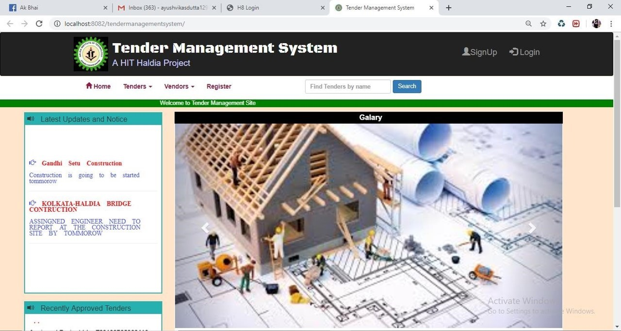

Figure-2.1 : It is the home page

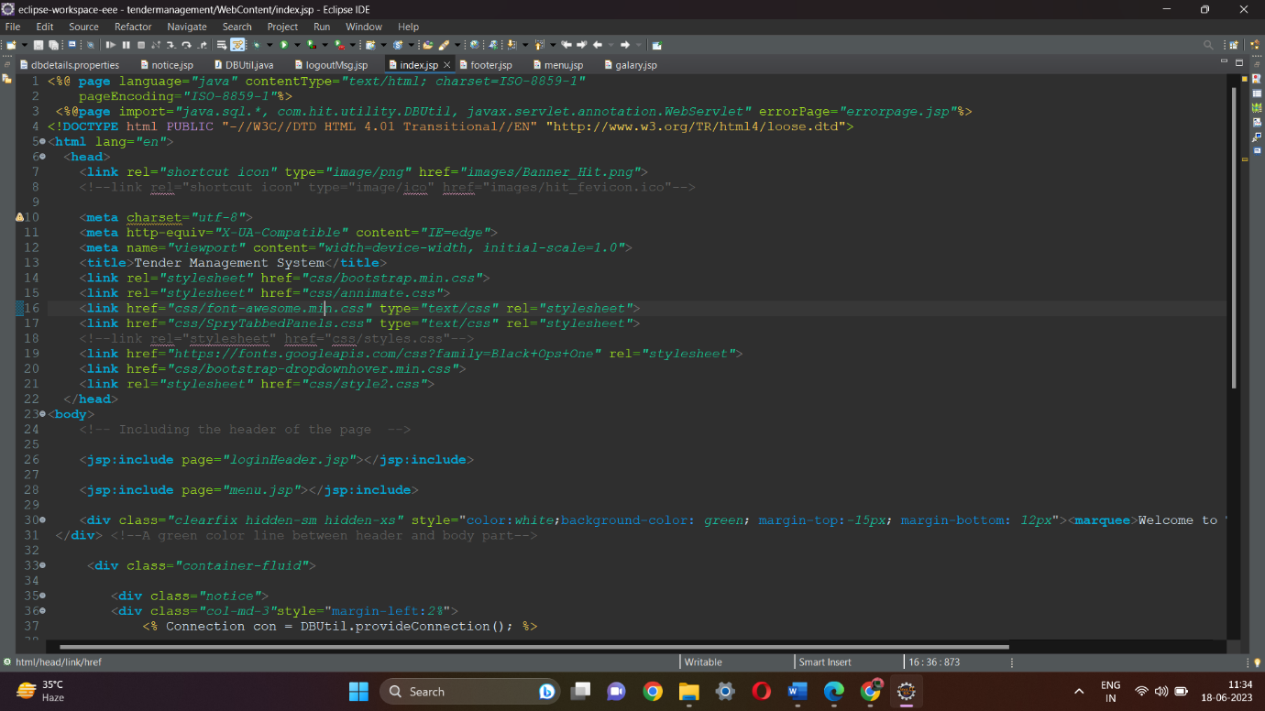Fig 2.2 : code for home page

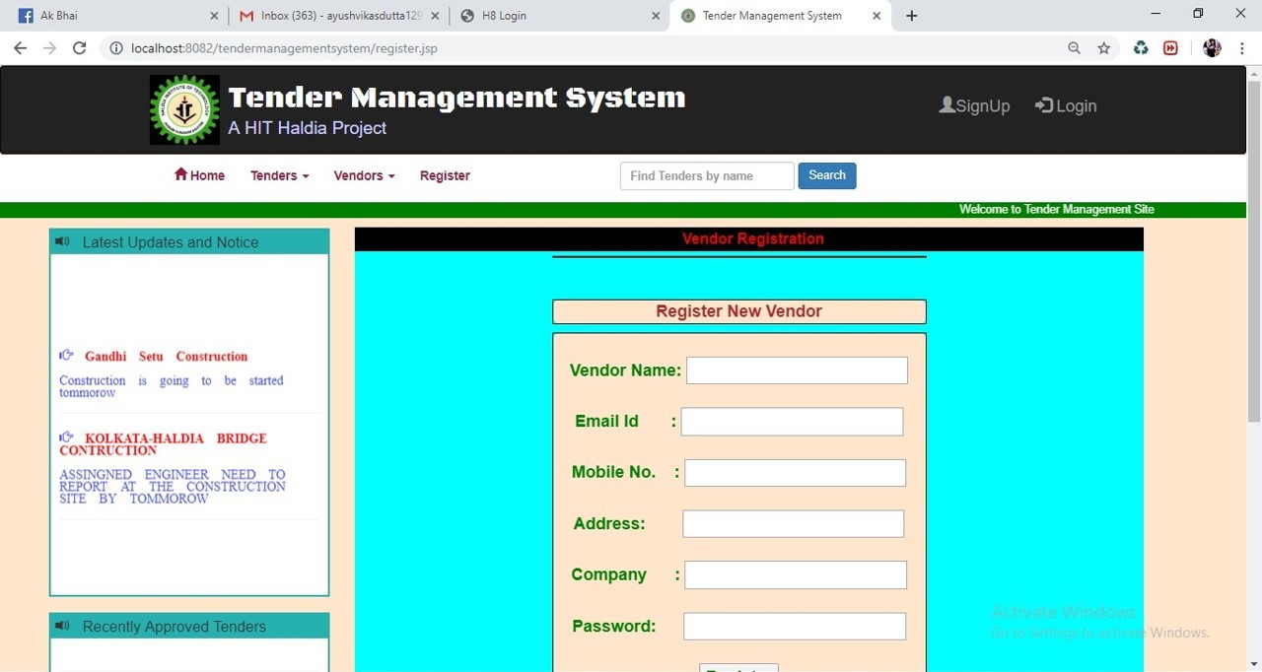

Figure-2 .3 **This is the page for register new vendor**

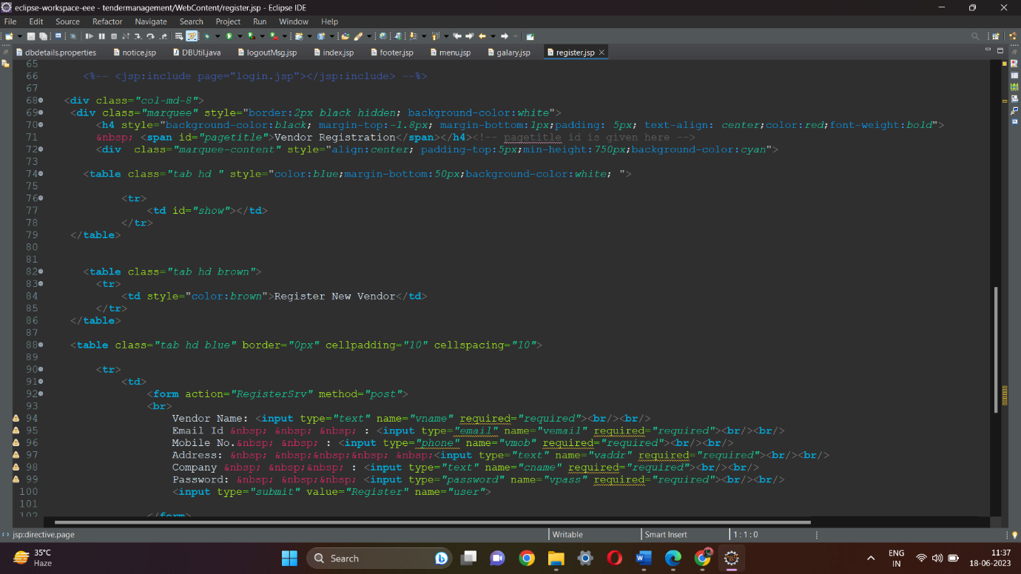

Fig 2.4 : Code for Register new Vendor

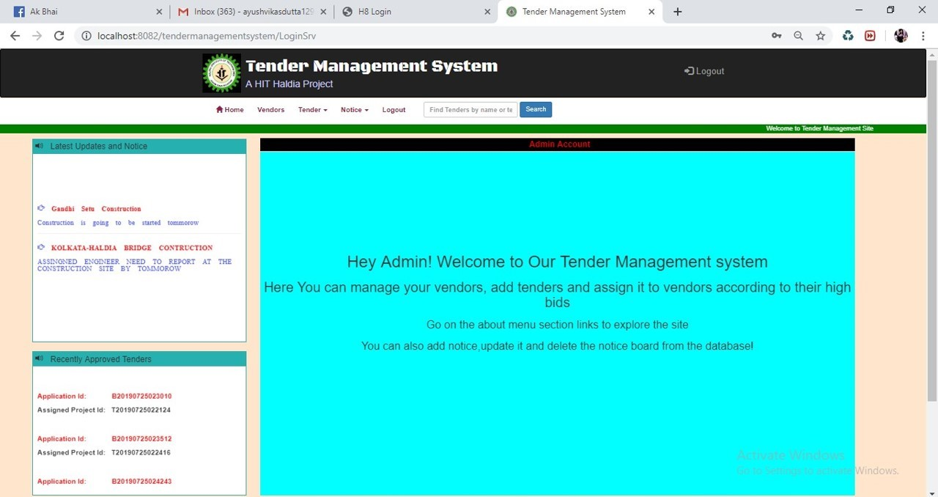

Fig 2.5 : Welcome page for New Vendor

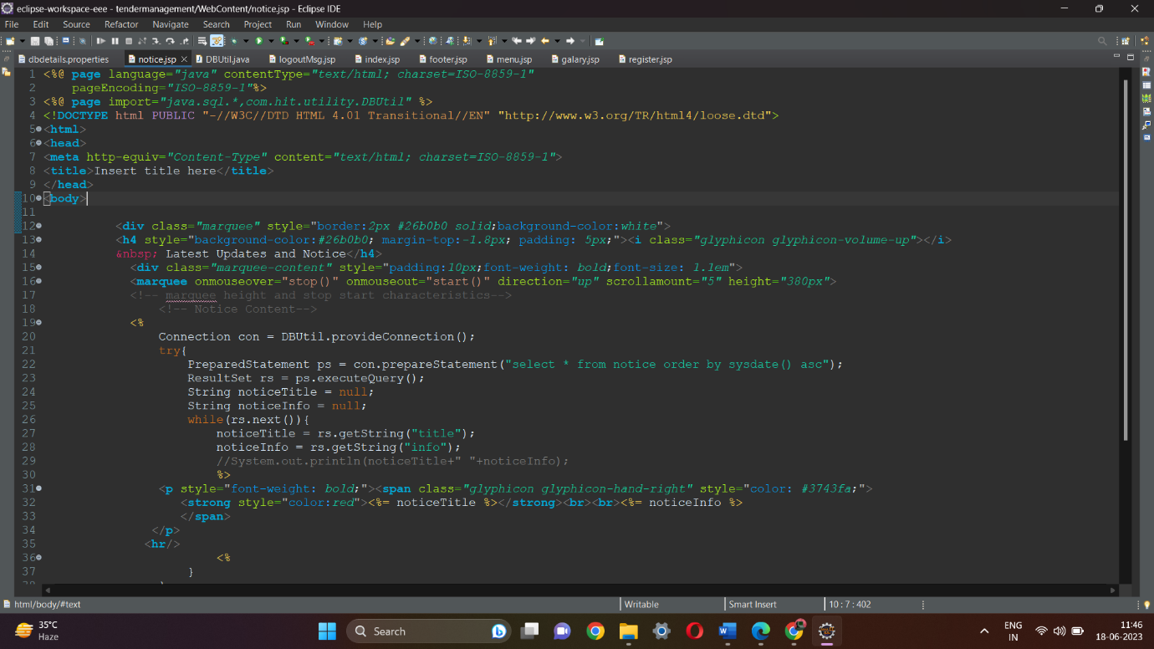

Fig 2.6 : Code for new Vendor

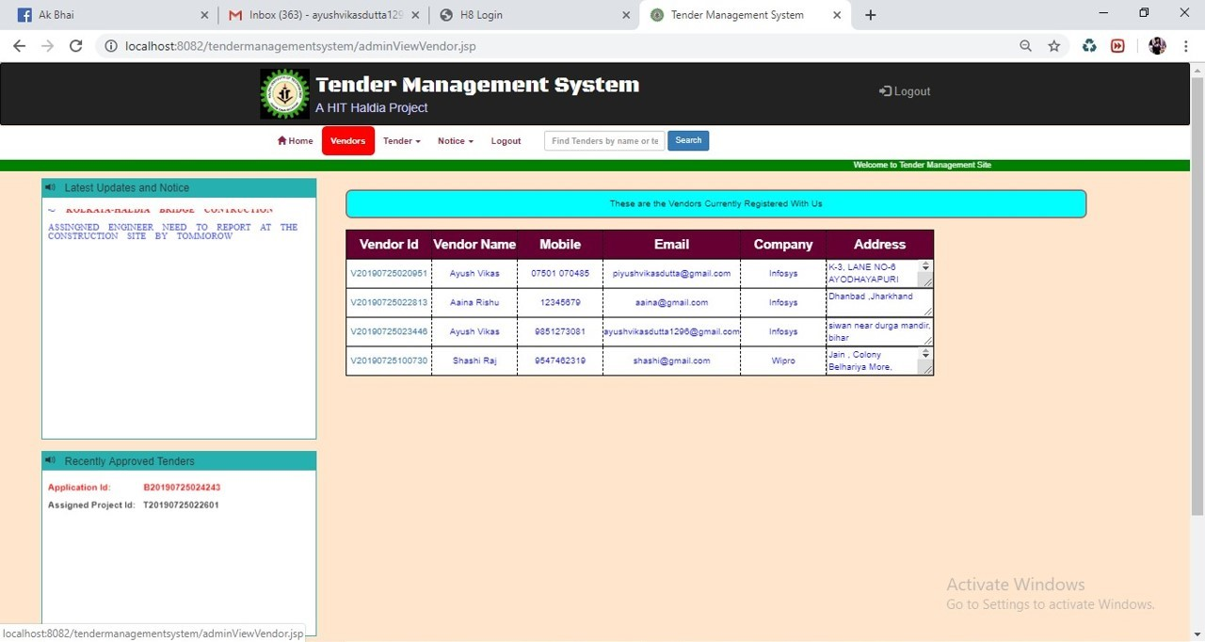

Figure-2.7 : view vendeor id and vendor name

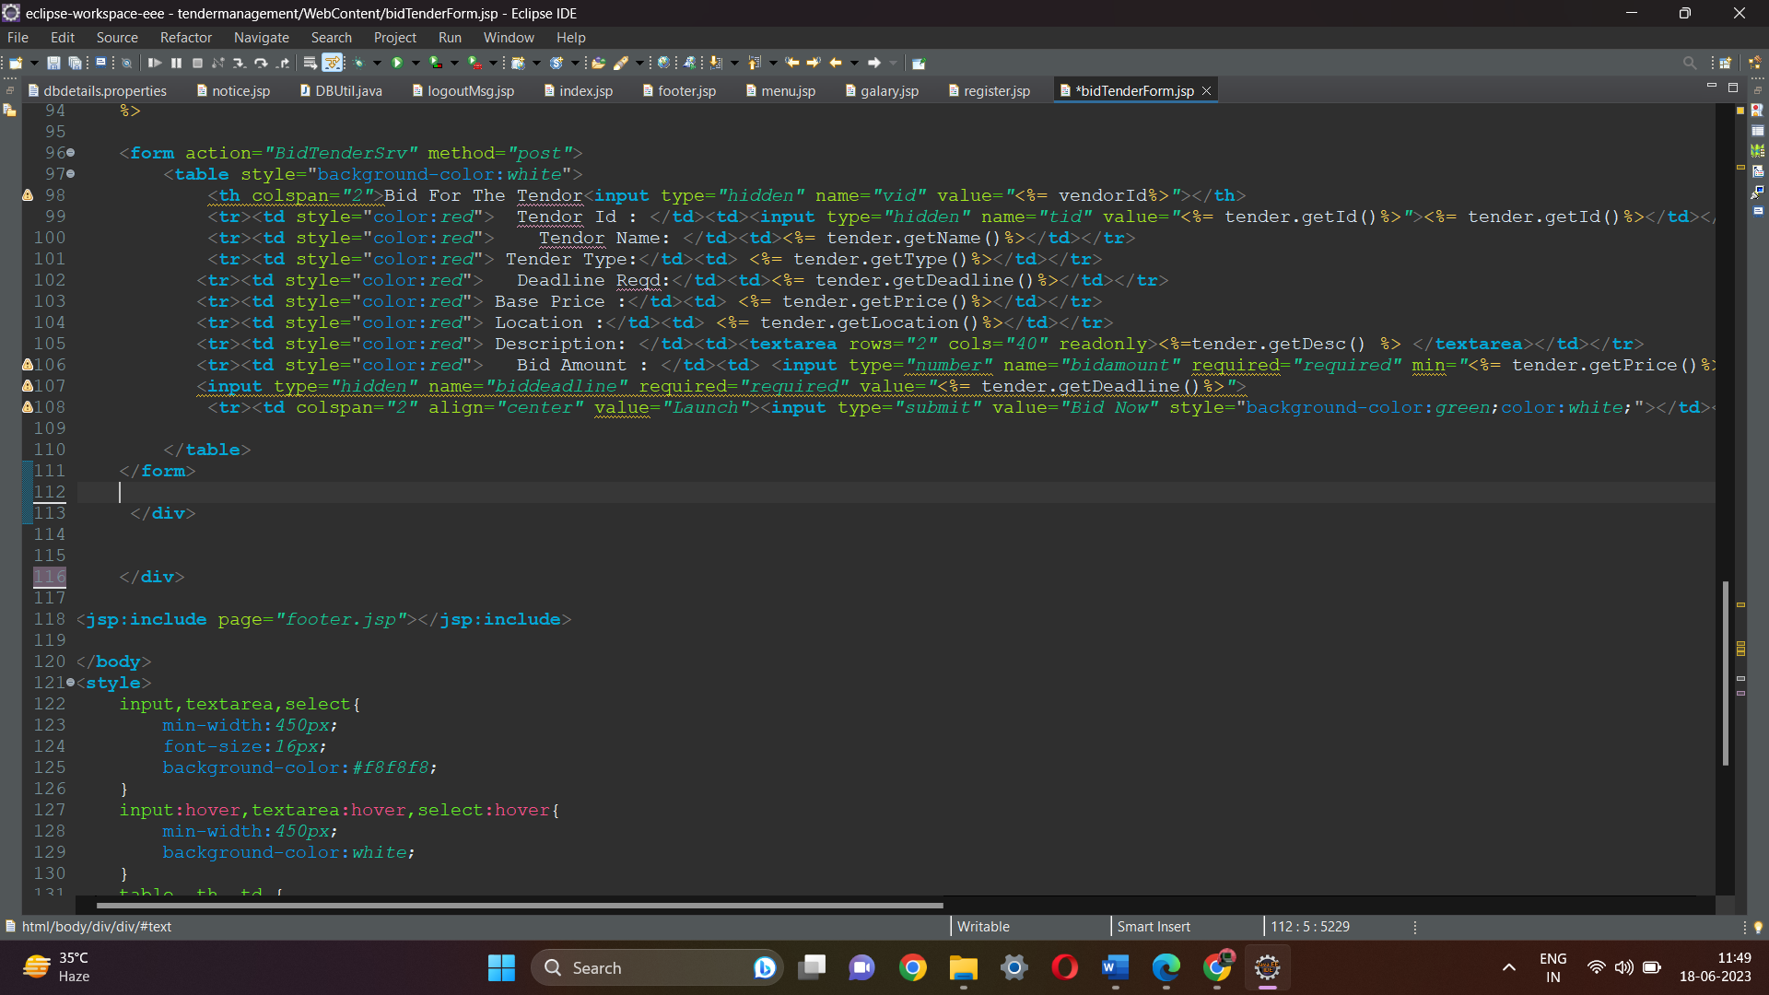

Fig 2.8 : Code for view vendor id and vendor name

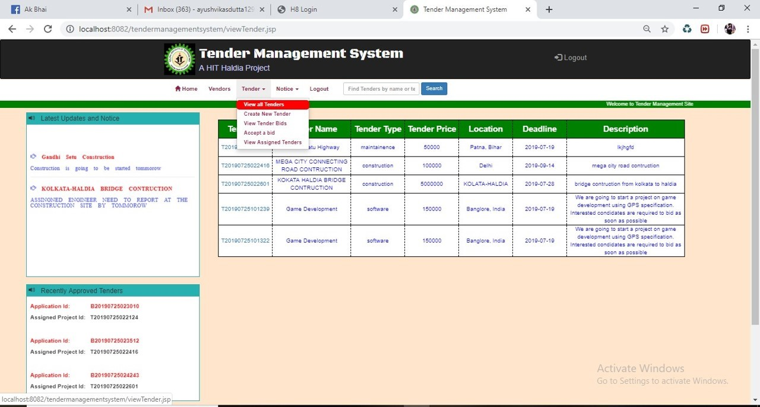

Figure-2.9 : view all tenders

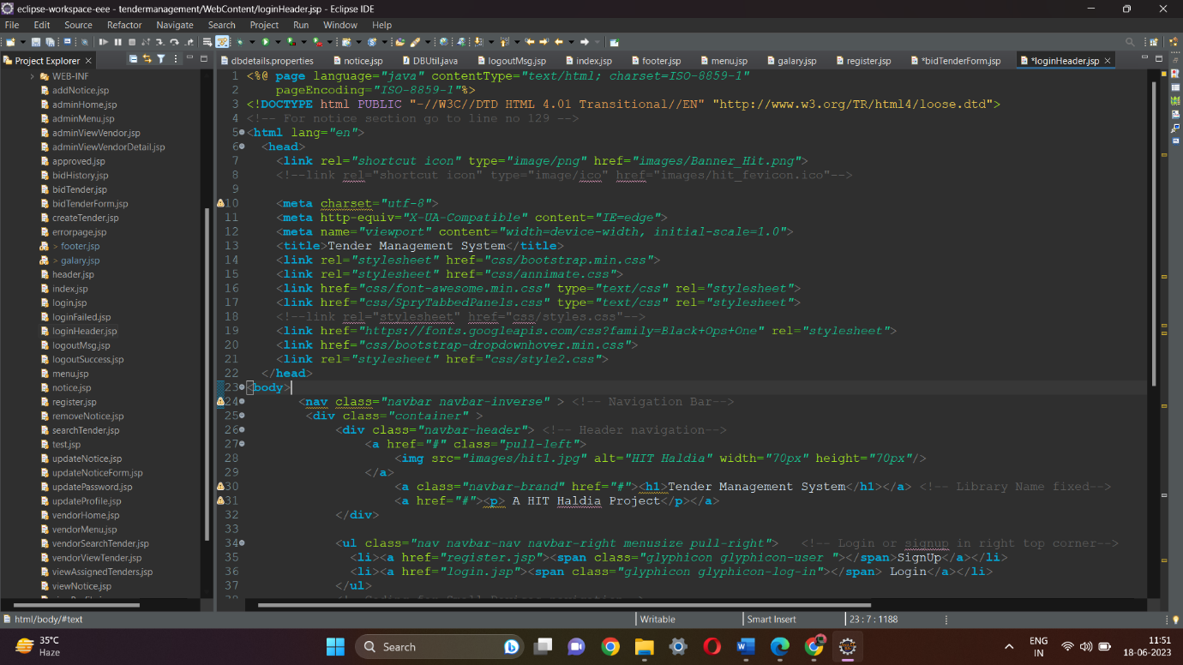

Fig 2.10 : Code for All tenders

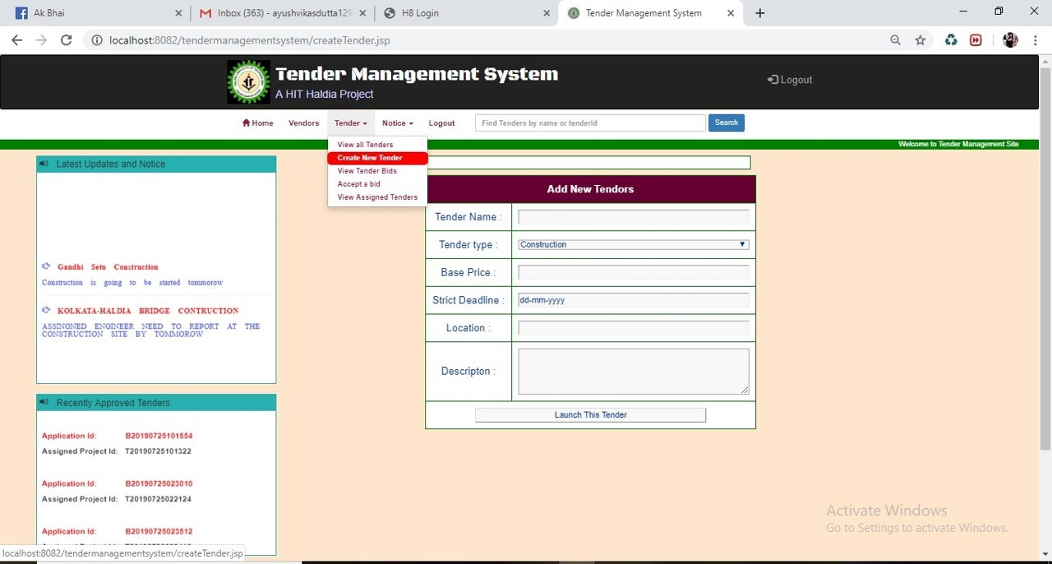

Figure- 2.11 : view page for create new tender

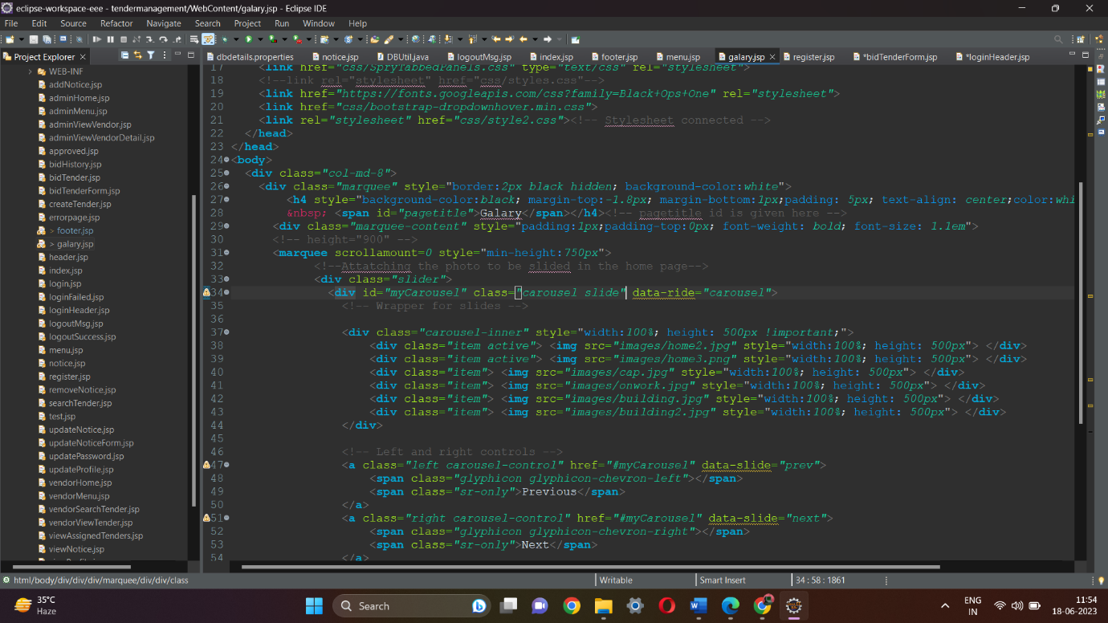

Fig 2.12 Code for create new vendor



Figure-2.13– The above page is displayed when admin clicks on “Bids” link. All the list of tenders appears and admin has to click on one of “View Bids” to view bids of supplier for a particular product.

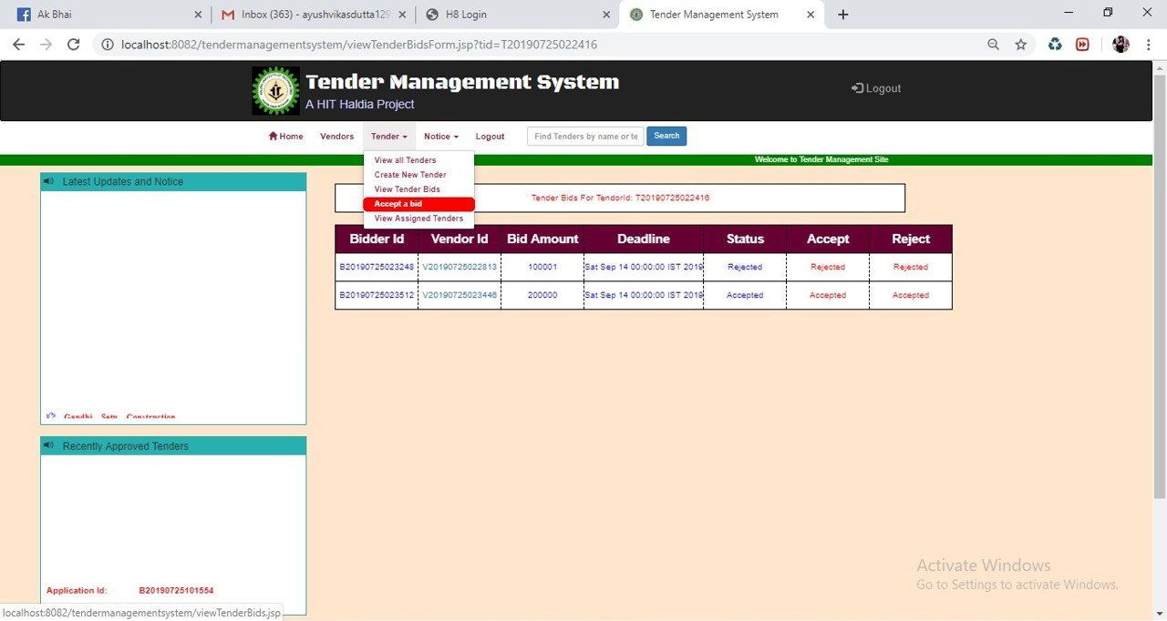

Figure-2.14 : It is for accept a bid

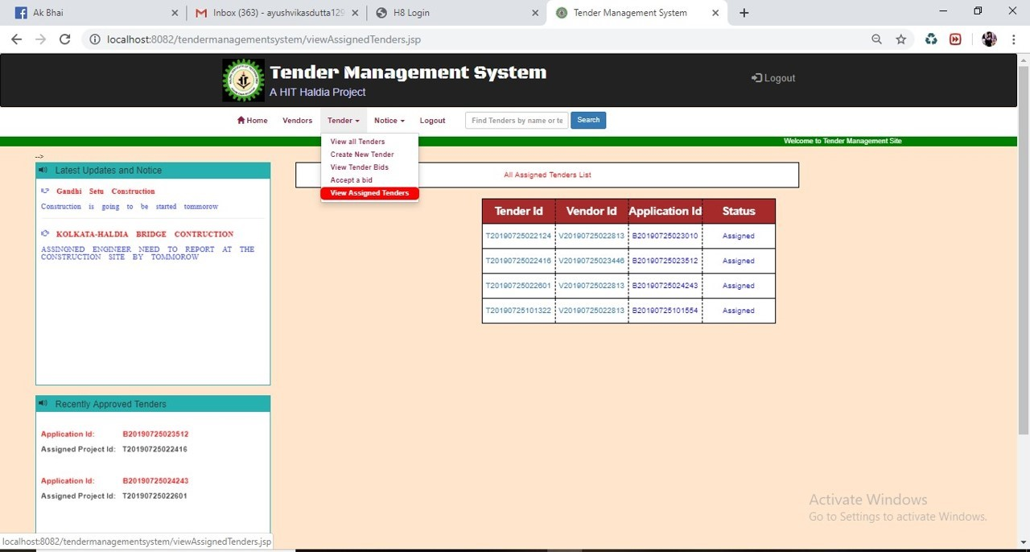

Figure-2.15: It is for viewing all the accepted tendors.

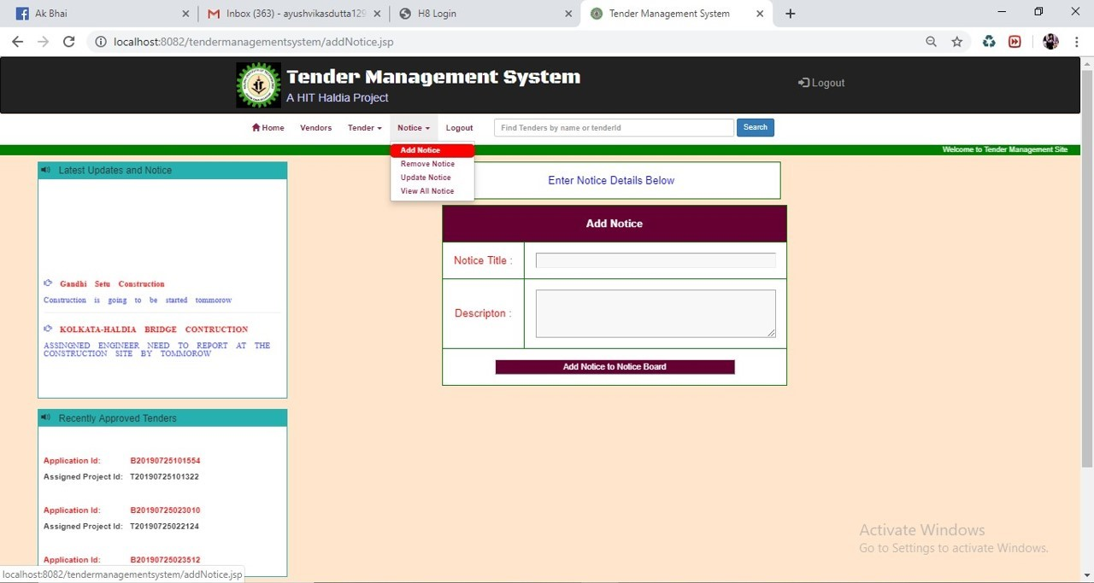

Figure-2.16 : It is for add a notice.

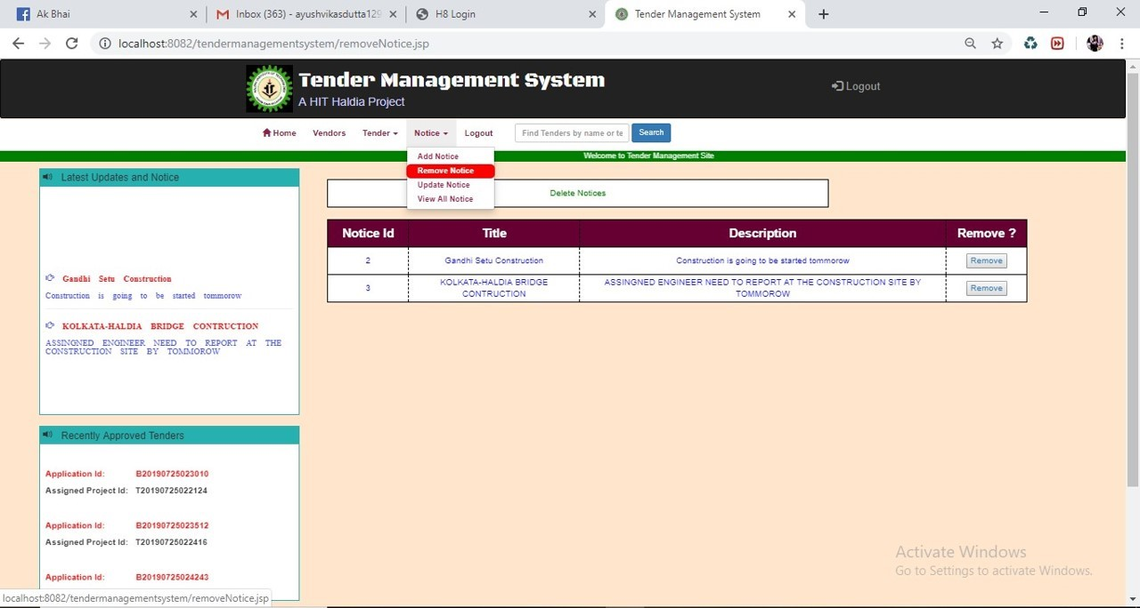

Figure-2.17 : It is for remove a notice.

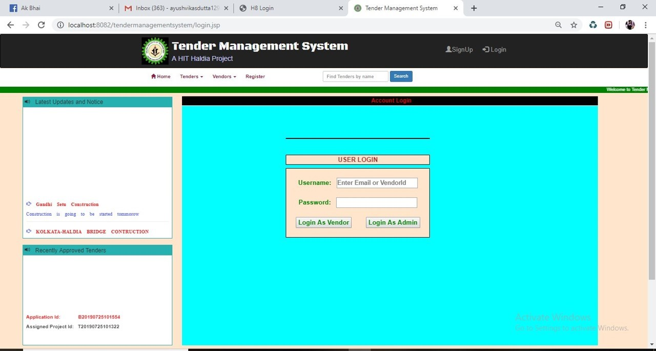

Figure-2.18: it is usser login screen

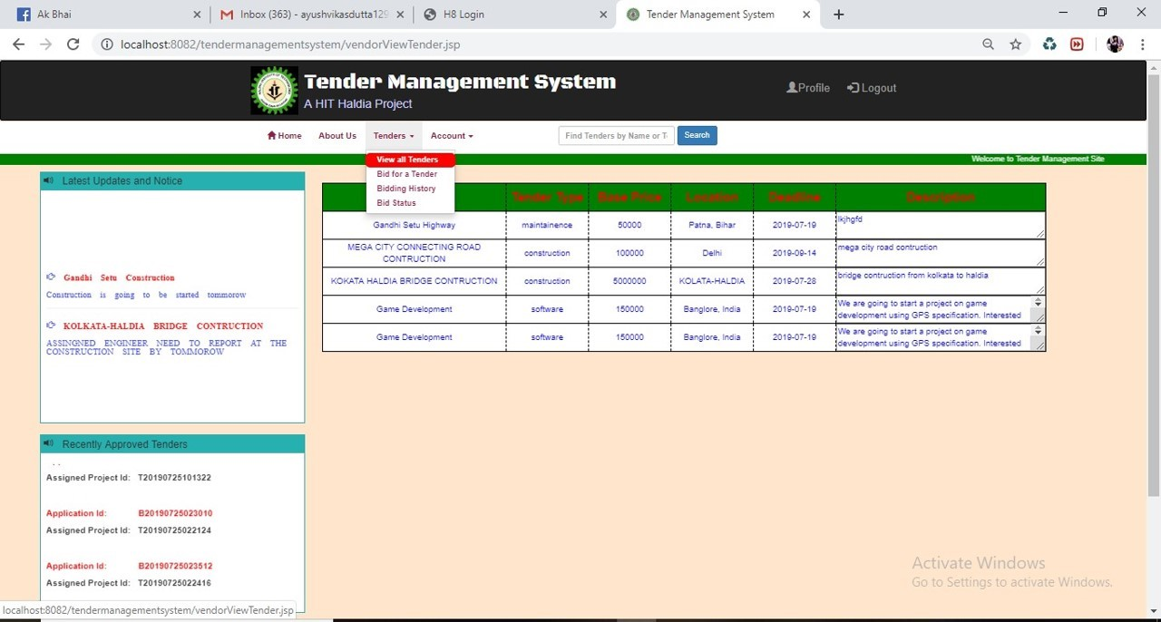

Figure-2.19 : it is the view all tender home screen page

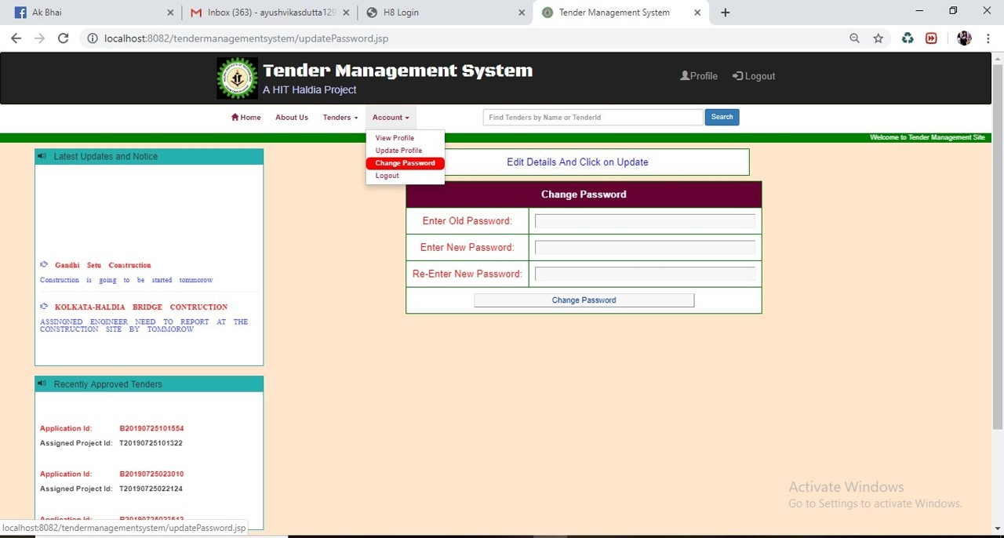

Figure-2.20 : It is for Change all the password.

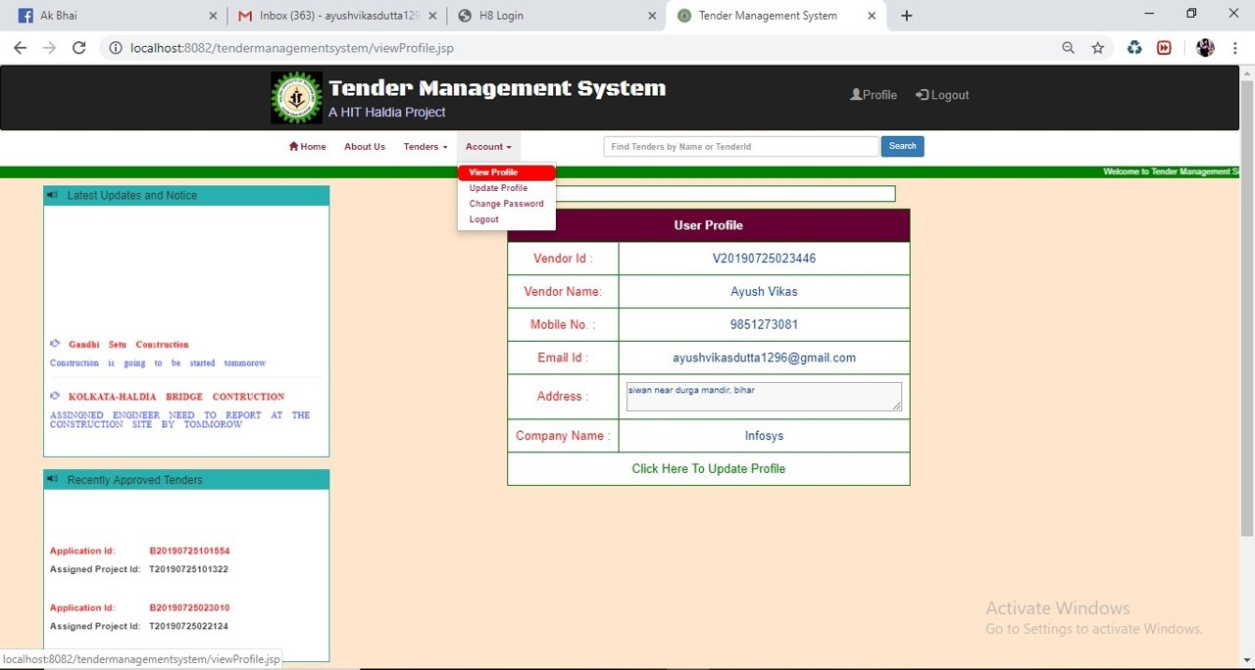

Figure-2.21 : It is for view the account details



Figure-2.22 for changing passwords



Fig 2.23 Code for galary